

THE UNIVERSITY OF JORDAN KING ABDULLAH II SCHOOL OF INFORMATION TECHNOLOGY
NEXT CHAPTER
Books recommendation system

Supervisors
Prof.Tahani Al-Khatib
DR. tamara almaraabeh
Students:
Malek Azzam Naif Alhweide | 0212094
Qusai Mohammad Abed Kanaan | 0215022
Omar Hussain Fahmi | 0210953
Ahmad Abdel Monem Muhsen | 0200777

Abstract
In an era dominated by digital content, readers often struggle to find trustworthy, community-driven platforms to discover, rate, and discuss books. This project introduces Next Chapter, a web-based platform designed to serve as a comprehensive database for books, mirroring the functionality and community features of IMDb but tailored specifically for the literary world. The website allows users to browse books by genre, author, and popularity, submit reviews, rate titles, and maintain personal reading lists.
Next Chapter aims to create a centralized hub for book lovers, offering detailed book profiles, reader-generated ratings, and comments to guide potential readers. The system is built using modern web technologies:Figma for UI/UX , HTML5,CSS(Bootstrap 5), JavaScript ,blender and after effect for the front-end and PHP and JavaScript back-end, along with a secure MYSQL database for data persistence. The platform also integrates authentication features, user profile management, and a responsive design to ensure accessibility across devices.
The main objectives of the project include enhancing book discovery through crowdsourced ratings and reviews, supporting personalized user interaction, and fostering an engaging online reading community. The website fills a significant gap in the market by offering a structured, scalable, and user-friendly platform specifically dedicated to books rather than general media.
We use Blender and After Effect for to make the transition effect on hero section between pages

Acknowledgment
First and foremost, I would like to express my sincere gratitude to Allah for granting me the strength and perseverance to complete this graduation project successfully.
I would like to extend my heartfelt thanks to my supervisor, Prof.Tahani Al-Khatib , DR. tamara almaraabeh, for their continuous support, valuable guidance, and constructive feedback throughout the development of this project. Their insights played a crucial role in shaping the direction of this work.
Lastly, I would like to thank all the instructors and staff in the Computer Information Systems Department at university of jordan for the knowledge and tools they have provided me throughout my academic career.

Table of Contants
1.0 Introduction 7
1.1 Motivation 7
1.2 Problem Statement 7
1.3 Aim and Objectives 7
1.4 Project Scope 8
1.5 Software and Hardware Requirements 8
1.6 Expected Outputs 9
1.7 Limitations 9
1.8 Project Schedule 10
2.0 Related Existing Systems 11
2.1 Overview about Existing Systems 11
2.2 Problems of Existing Systems 12
2.3 Proposed Solutions in the New System (NextChapter) 12
3.0 SYSTEM REQUIREMENTS ENGINEERING AND ANALYSIS 12
3.1 Feasibility Study: 12
3.1.1 Technical Feasibility: 12
3.1.2 Operational Feasibility 14
3.1.3 Economic Feasibility 15
3.1.4 T Legal Feasibility 18
3.2 Requirements gathering techniques 18
3.2.1 T Stakholder Interview 18
3.2.2 T Questionnaires 20
3.3 The targeted users (Stakeholders) 23
3.4 functional requirements definition and specification 25
3.5 Non-functional requirements 26
3.6 Usability and user experience goals. 27
4.0 SYSTEM DESIGN 28
4.1 Architecture Design 28
4.2 Entity Relationship Diagram (ERD) 28
4.3 Enhanced Entity Relationship Diagram 29
4.4 UML Use Case Diagram 30
4.5 UML Sequence Diagram 35
4.6 Database Design 75
5.0 PROJECT IMPLEMENTATION 79
5.1 Implementation requirements 79
6.0 SYSTEM TESTING AND INSTALLATION 79
6.1 Testing 79
6.2 Heuristic Evaluation 80
6.3 Cooperative Evaluation 81
6.4 System Installation 81
6.5 User Manual 82
7.0 PROJECT CONCLUSIONS AND FUTURE WORK 89

List of Figures
Figure 1 pert diagram 11
Figure 2Questionnaires 1 20
Figure 3 Questionnaires2 20
Figure 4 Questionnaires 3 21
Figure 5 Questionnaires 4 21
Figure 6Questionnaires 5 22
Figure 7Questionnaires6 22
Figure 8Questionnaires7 23
Figure 9 Architecture Design 28
Figure 10 Entity Relationship Diagram (ERD) 28
Figure 11 Enhanced Entity Relationship Diagram 29
Figure 12 Use Case Diagram-Authentication system 30
Figure 13Use Case Diagram-Forget password 31
Figure 14 Use Case Diagram-update user information 32
Figure 15 Use Case Diagram-Rating and comments 33
Figure 16Use Case Diagram-user interaction system 34
Figure 17 login-Sequence Diagram(FR1) 37
Figure 18 Logout -Sequence Diaram (FR5) 42
Figure 19 Sequence Diagram-forget password flow 44
Figure 20Sequence Diagram-Update UserName 46
Figure 21Sequence Diagram-Update Email 48
Figure 22Sequence Diagram-Update Password 50
Figure 23Sequence Diagram-rating 52
Figure 24 Sequence Diagram- 56
Figure 25 Sequence Diagram-button interaction 59
Figure 26 Sequence Diagram-select genre 61
Figure 27 Sequence Diagram upload user photo 63
Figure 28 Sequence Diagram search engine 65
Figure 29 Sequence Diagram randomr recommendation 67
Figure 30 Sequence Diagram book details 69
Figure 31 Database Design 76
Figure 32 Database Design 2 77
Figure 33 Database Design 3 78
Figure 34 Database Design 4 78
Figure 35 First page 1 82
Figure 36 First page 2 83
Figure 37 sign in page 83
Figure 38 sign up page 84
Figure 39 prefrances page 84
Figure 40uploade pfp 85
Figure 41 home page 1 85
Figure 42 home page 2 86
Figure 43 home page 3 86
Figure 44 home page 4 87
Figure 45 Recommendation page 1 87
Figure 46 Recommendation page 2 88
Figure 47 about page 88
Figure 48 profile page 89

List of Table
Table 1 Software and Hardware Requirements 8
Table 2 tasks 10
Table 3 Devlopment cost 15
Table 4 Hardware and software costs 15
Table 5 operating costs 16
Table 6 fixed coxtx 16
Table 7 constant costs 16
Table 8 tangible benefits 17
Table 9 payback analysis 17
Table 10 functional requirements 25
Table 11 Non-functional requirements 26
Table 12 login sequence diagram 35
Table 13 signup sequence diagram 38
Table 14 Register-Sequence Diagram (FR2) 40
Table 15 logout 41
Table 16 forgot password 43
Table 17 update user name 45
Table 18 update email 47
Table 19 update password 49
Table 20 rating 51
Table 21 comments 55
Table 22 button interaction 58
Table 23 select genre 60
Table 24 upload photo 62
Table 25 search bar 64
Table 26 random recommendation 66
Table 27 book details 68
Table 28 Tasks and Observations: 81

1.0 Introduction

1.1 Motivation
In today's digital world, where access to information is instant and entertainment options are abundant, the love of reading often fades into the background. While platforms like IMDb serve movie and TV enthusiasts, there is a clear gap in the existence of a trustworthy and equally engaging website for book lovers. Most current platforms lack intuitive design, social interaction, and comprehensive content organization. This project aims to create a centralized and user-friendly platform that supports book discovery, discussion, and community contribution. The motivation stems from a desire to encourage more people to read, rate, and write reviews in a way similar to the success of movie platforms.

1.2 Problem Statement
Despite the availability of a vast number of books online, there is no widely adopted platform that allows users to explore books by genre, popularity, or rating while providing a social and interactive environment. Most existing websites lack usability or appeal, forcing users to rely on scattered sources and personal recommendations. This project aims to solve this issue by creating a comprehensive, intuitive, and community-driven website for book selection and interaction.

1.3 Aim and Objectives
Project Aim:
To develop a web-based platform inspired by IMDb for discovering, rating, and reviewing books that improves user experience, builds a community of readers, and helps in making informed reading decisions.
Project Objectives:
- Develop a User-Friendly Interface: Design a clean, responsive, and intuitive user interface using modern front-end and graphics technologies.
- Implement an Integrated Back-End System: Create a robust and secure back-end for managing data, authentication, and content.
- Streamline Service Requests and Reporting: Enable users to suggest books, shar rating and comments and request features easily.
- Ensure Data Security and Privacy: Use encryption and secure authentication methods to protect user data.
- Personalize User Experience: Use user preferences and suggesting from our redres to deliver personalized recommendations.
- Promote Sustainability and Scalability: Build the system in a scalable manner using a flexible architecture that supports future expansions.

1.4 Project Scope
The scope of the NextChapter project includes the following aspects:
- User Interface Design and Development: Build an intuitive and responsive front-end using technologies like html,css, js and graphics to ensure ease of use across devices.
- Back-End System Integration: Implement strong server logic using js , php and , with MYSQL hosted on railway for efficient data management.
- Data Security and Privacy: Use secure authentication mechanisms and encrypted storage to maintain user confidentiality.
- Personalization Features: Integrate recommendation systems and personalized experiences based on reading history and preferences.
- Maintenance and Support: Provide ongoing support for the platform, including regular updates and bug fixes.
- Scalability and Global Application: Design the platform for growth, with multi-language support and a global user base.

1.5 Software and Hardware Requirements
**** | Resourses | Quantity | Unit Price (JD) | Total Price
HD1 | Laptops | 4 | 600 | 2400
HD2 | internet connection | 1(annual) | 600 | 600
HD3 | Data base Server(Railway) | 1(annual) | 650 | 650
HD4 | Hosting Server | 1 | 1500 | 1500
SW1 | VS Code | For (free) | 0 | 0
SW2 | PHP | For (free) | 0 | 0
SW3 | Figma | 1(monthly) | 30 | 30
SW4 | After effect | 1(monthly) | 20 | 20
SW5 | Blinder | 1(free) | 0 | 0
SW6 | Git and Github | 1(free) | 0 | 0
SW7 | Canva | 1(free) | 0 | 0
SW8 | Host name | 1 | 30 | 30
Table 1 Software and Hardware Requirements

1.6 Expected Outputs
Upon completion, the outputs of the Next Chapter project will include:
- A Fully Functional Next Chapter System: A complete web application for browsing books, reviewing them, share rating and comments and fostering community interaction.
- User-Friendly Website: A modern, responsive, and intuitive interface that improves the user experience.
- Secure Data Management and Privacy Compliance: Strong systems for secure login, data protection, and privacy law compliance.
- Sustainability and Efficiency: Efficient performance with low resource usage, designed for long-term operation and scalability.

1.7 Limitations
Despite its features and benefits, the Next Chapter system faces the following limitations:
- Initial Implementation Costs: Developing the full system may require a significant investment in design, development, and hosting.
- System Reliability and Downtime: Outages or bugs may affect platform availability.
- Data Security and Privacy Risks: There is always a potential risk of data breaches despite best efforts.
- Dependence on Internet Connectivity: The platform requires a stable internet connection for use.
- Legal and Regulatory Compliance: Adhering to data protection and copyright laws can be complex.
- Ongoing Maintenance and Updates: The system requires regular maintenance and updates, which demand ongoing resources.
- Data Management and Accuracy: Relying on user-generated content may lead to inaccuracies or outdated information.

1.8 Project Schedule
The project is planned to be completed over a 16-week timeline, as follows:
Task | Description | Duration | Dependency | Responsiblelty
Task1 | Gather user requirements | 3 Days | None | Qusai , malek
Task2 | Define objectives | 3 Days | Task1 | Omar
Task3 | Conduct feasibility study | 4 Days | Task1 | Ahmad
Task4 | Gather System requirements | 1 Days | Task2, Task3 | Qusai
Task5 | Design user interface | 12 Days | Task1 | Malek,omar
Task6 | Design database schema | 3 Days | Task4, Task5 | Qusai
Task7 | Design system functionalities | 5 Days | Task6 | Omar
Task8 | Develop and test system components | 30 Days | Task7 | Qusai,malek,ahmad
Task9 | Test the system with the users | 7 Days | Task8 | Omar
Task10 | Train users and stakeholders | 4 Days | Task9 | Ahmad
Task11 | Deploy the system | 1 Day | Task10 | malek
Table 2 tasks

Phase | Duration | Description
Requirement Analysis | 11 days | Collect user needs, define scope and technologies used
UI Design | 12 days | Create Graphics videos , user flows, and interface structure
Back-End Development | 23 days | Set up server, database, and back-end
Front-End Development | 15 days | Implement front-end and connect it to back-end
Testing and Debugging | 7 days | Perform testing, fix bugs, and optimize performance
Deployment and Delivery | 5 days | Host the application and finalize project documentation

Table 3 project schedule

Total Project Duration: 73 days (10.4 Weeks) (Approximately 2.4 Months)
critical path = 65 Days
T1 → T5 → T6 → T7 → T8 → T9 → T10 → T11

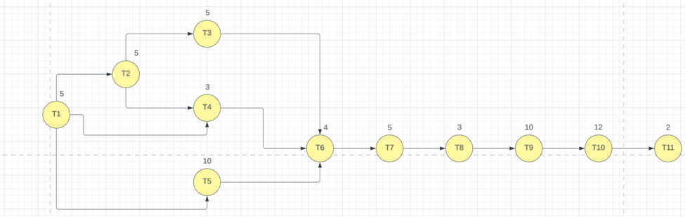
Figure 1 pert diagram

2.0 Related Existing Systems
The focus of this section is on existing related works, their problems, and the solutions available for them.

2.1 Overview about Existing Systems
Current book discovery and rating platforms mainly rely on digital databases or social recommendation networks such as Goodreads and LibraryThing. These systems offer basic services such as adding books, rating them, writing reviews, and creating reading lists.
However, most of these platforms lack a unified experience that integrates all features with a modern design and seamless usability.

2.2 Problems of Existing Systems
- Lack of Feature Integration: Features like reviews, ratings, and recommendations are not deeply interconnected, leading to a fragmented user experience.
- Outdated User Interfaces: Many platforms use old-fashioned designs that are not user-friendly.
- Limited Personalization: Current systems do not effectively utilize user preference data to deliver personalized content.

2.3 Proposed Solutions in the New System (NextChapter)
- Unified and Integrated System: All features are built into one platform that connects reviews, ratings, and book recommendations.
- Modern and Responsive Interfaces: Built with HTML, CSS, Bootstrap and JavaScript. Also , have an animations using Blender
- Personalization: The system will recommend books based on user preferences and random recommendation from our readers .

3.0 SYSTEM REQUIREMENTS ENGINEERING AND ANALYSIS
This Chapter includes all the Feasibility study sides (Technical, Operational, Economic and Legal). Also, we defined the Stakeholders and the functional-nonfunctional requirements with a brief description about them.

3.1 Feasibility Study:

3.1.1 Technical Feasibility:
The successful implementation of NEXTCHAPTER, a book discovery and rating platform, relies on a detailed evaluation of its feasibility from technical perspective. This section highlights the essential elements required to confirm that the proposed system is both practical and prepared for successful deployment and ongoing support.
To ensure user-friendliness, and long-term viability, the technology stack consists of:
- Front-End Development: HTML, CSS, and JavaScript lay the foundation for structure, styling, and interactive behaviors. Bootstrap 5 enhances responsiveness, consistency, and mobile compatibility.

  - HTML5 enables semantic layout and flexible multimedia integration.
  - CSS3 is used for layout, responsive design, and visual effects.
  - JavaScript allows real-time interactivity, form validations, and dynamic content updates.
  - Bootstrap 5 reduces custom CSS coding time with ready-made responsive components

- Design and Graphics
  - Blinder to create a graphics video to enhance user experience
  - After effect and canva
- Back-End Development: PHP is the backbone for server-side logic. Laravel’s vendor and composer packages are selectively used to implement PHPMailer and mail routing services
  - Core PHP handles data validation, session management, and authentication.
  - JS used to fitch and request from Coogle book API to insure performance and reduce server overloading.
  - Laravel components, though limited, enhance structure for the email module.
- Database Management: MySQL .
  - Hosted on Railway for easier visual management during development.
- Frameworks and Tools:
  - Composer is a dependency manager for handling PHP packages like PHPMailer.
  - Version Control: Git/GitHub is used to track changes and enable collaboration.

3.1.2 Operational Feasibility

- Alignment with Business Objectives:
  - Promotes reading, and builds academic reputation.
  - Encourages users participation and user-generated content.
- Resource Availability:
  - Uses free, open-source tools.
  - Hosting on budget-friendly services.
  - No need for advanced hardware.
- Ongoing Maintenance and Support:
  - Periodic user surveys to guide updates.
- 5. Scalability and Maintenance:
  - The system must be scalable to accommodate the growing needs of the users
- Low Operational Overhead:
No model training , retraining, or data science expertise needed to maintain the system..

3.1.3 Economic Feasibility
- Development Costs
The development costs include all expenses related to personnel, hardware, software necessary to bring the NEXTCHAPTER system to fruition.

Number | Employee | Num of employees | Total Cost (JD)
1 | Front-End Development | 2 | 1000
2 | UI/UX Design | 1 | 100
3 | Back-End Development | 2 | 900
4 | Data base specialist | 1 | 400
5 | Testing and Debugging | 1 | 500
6 | Project Management | 1 | 300
Total |  |  | 3200
Table 3 Devlopment cost
Total Development Costs: 3.200 JD

Hardware and Software Development Costs:
Category | Description | Estimated Cost
Development Tools | IDEs (VS Code – free), GitHub | 0
Design Tools | Canva Pro + Adobe After Effects (1 month license) | 80
Hosting Platform | Railway (development phase hosting) | 10
Domain Registration | Custom domain name | 10
Production Hosting | Shared hosting (e.g., Hostinger, DigitalOcean) | 60
Total |  | 162 JD
Table 4 Hardware and software costs

- Operating Costs:
The ongoing costs of operating the system include maintenance, updates, hosting, and other necessary expenses to ensure smooth operation
Category | Description | Estimated cost
Hosting & Domain | Ongoing web hosting + domain renewal | 80
Email Services | PHPMailer with SMTP | 0
Maintenance and Updates | Bug fixes, content updates, small feature additions | 300/year
User Feedback and Surveys | Google Forms / Free survey tools | 0
Total (Yearly Ops) |  | 380 JD
Table 5 operating costs
Fixed and Variable costs:
service | Cost (annual)
Internet connection | 600
Host & domain | 960
servers | 650
total | 2210 JD
Table 6 fixed coxtx

Constant costs (for one time):
Service | Quantity | Cost
Devlopment team | 1 | 3200
Labtops | 4 | 2400
Table 7 constant costs

- Tangible Benefits:
The tangible benefits include direct cost savings and efficiencies gained from the implementation of the system, which contribute to the project’s financial viability.
Number | Tangible Benefits | Value
1 | Decrease in Number of staff | 1500
2 | Marketing and sponsers | 4500
Total |  | 7000
Table 8 tangible benefits

- Intangible Benefits:
  - Academic collaboration.
  - Increased student engagement.
  - Contribution to reading culture.
  - Time saved

- Payback Analysis:

Year | Initial cost | Operation costs(fixed) | Maintenance | Tangible benefits | Cumulative benefits | Net benefits | Cumulative net benefit
Year 0 | 5,600 (Laptops + Dev Team) | 0 | 0 | 0 | 0 | 5600 | 5600
Year 1 | 0 | 2210 | 380 | 7000 | 7000 | 4410 | 1190
Year 2 |  | 2210 | 456 | 7000 | 14000 | 4334 | 3144
Year 3 |  | 2210 | 547 | 7000 | 21000 | 4243 | 7387
Year 4 |  | 2210 | 656 | 7000 | 28000 | 4134 | 11521
Year 5 |  | 2210 | 787 | 7000 | 35000 | 4003 | 15524
Table 9 payback analysis
(Maintenance increases 20% annually; Operating cost is constant at 2,210 JD.)
- Payback Period: The project reaches a positive NPV in the between of Year 2 and Year 3 (≈ 2.4 years), indicating that the initial investment is fully recovered slightly before the end of the third year.
- Lifetime ROI: The ROI for the system over its expected lifetime of five years is calculated to be 27702 %.
- Annual ROI: This translates to an annual ROI of 77.6 %.
- Net Present Value (NPV): The total NPV over five years is 9602.8JD, indicating a substantial return on the initial investment

3.1.4 T Legal Feasibility
- Licensing and Software Use:
  - Educational Licenses: Tools used under institutional policy.
  - Open Source: Fully compliant usage of PHP, Bootstrap, Composer , blinder.
- Contractual & Vendor Compliance:
  - Due diligence before integrating any 3rd-party service.
  - Evaluate Google Book API usage restrictions.
- University Policies:
  - Respect for digital resource policies.
  - Adherence to plagiarism and code originality rules.
- Ethical & Legal Awareness:
  - Hypothetical Legal Consultation: If platform goes public.
  - Incident Response Plan: Internal protocol for data breaches.

3.2 Requirements gathering techniques

3.2.1 T Stakholder Interview
1. Interview with Readers (ST1):
Q1: What do you look for in a book discovery platform?
Sample Answer:
“I want personalized recommendations, honest reviews from other readers, and an easy way to keep track of books I’ve read or want to read.”

Q2: What features would make you use NEXT CHAPTER regularly?
Sample Answer:
“A clean interface, fast search, user-generated lists, and the ability to comment on or rate books. Also, an option to connect with friends would be great.”

2. Interview with Authors (ST2):
Q1: How important is reader feedback to you?
Sample Answer:
“Extremely important. It helps me understand what readers enjoy and where I can improve. Having access to analytics or comments on my books would be a game-changer.”
Q2: Would you be willing to interact with readers on a platform like Next Chapter?
Sample Answer:
“Yes, I’d love to answer questions or thank readers for their support. It would help build a loyal following.”
3. Interview with Library Staff (ST3):
Q1: What are the key challenges you face in catalog management and reader engagement?
Sample Answer:
“Keeping the catalog updated, managing user demand, and promoting underutilized books are constant challenges. A platform that connects our catalog to a digital system could really help.”
Q2: How do you see next chapter supporting your work?
Sample Answer:
“If integrated well, it could increase book circulation and help us understand what users are interested in, making our acquisition decisions better.”
4. Interview with Developers (ST4):
Q1: What are the biggest concerns in building a platform like Next chapter?
Sample Answer:
“Ensuring data security, handling user load as the platform grows, and maintaining clean code are top priorities. We also have to make sure it’s mobile-friendly and accessible.”
Q2: How should updates and maintenance be handled?
Sample Answer:
“Scheduled downtimes, automated testing before pushing new features, and clear documentation. We also recommend version control and CI/CD pipelines for smooth deployment.”

3.2.2 T Questionnaires

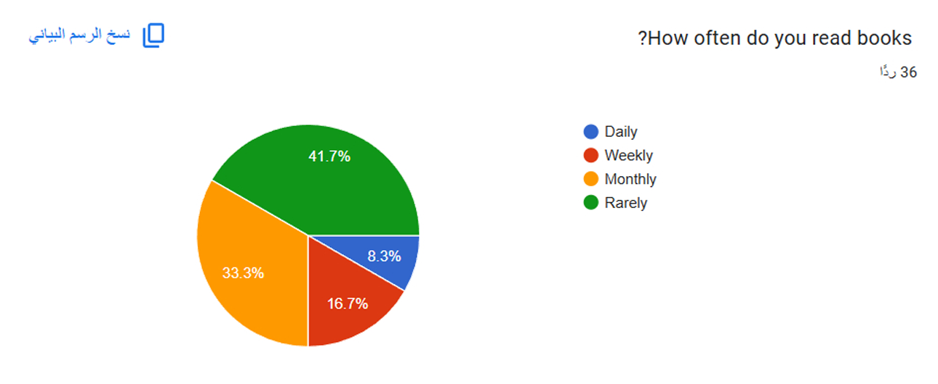
Figure 2Questionnaires 1

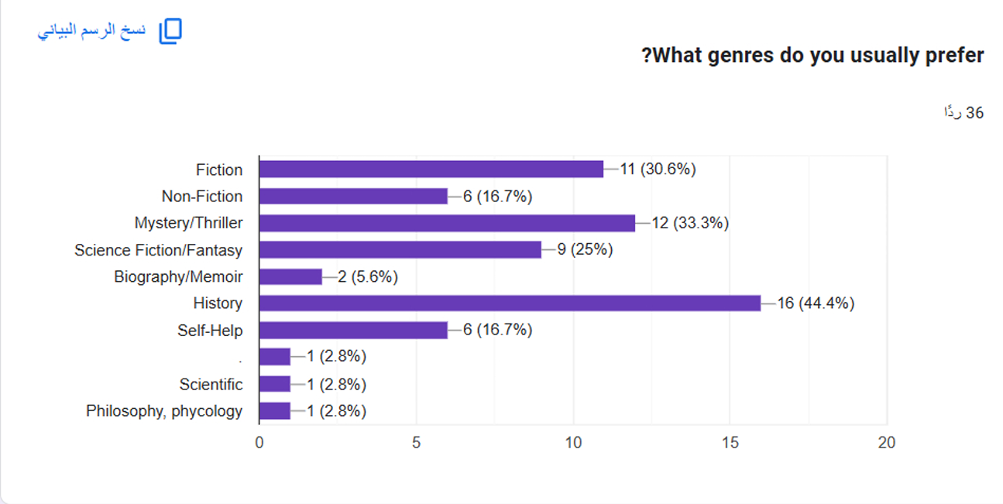
Figure 3 Questionnaires2

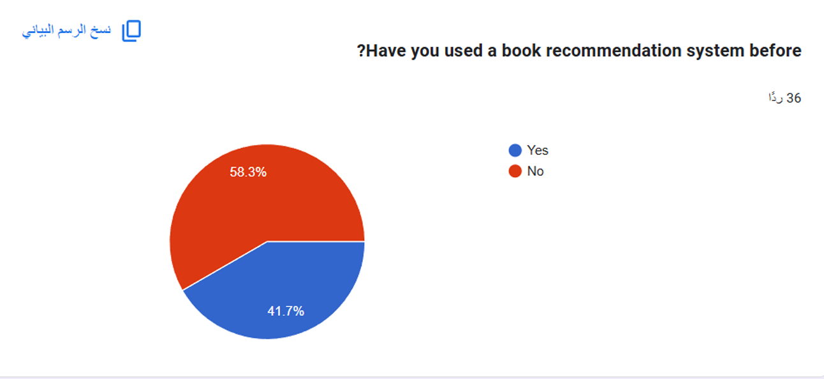
Figure 4 Questionnaires 3

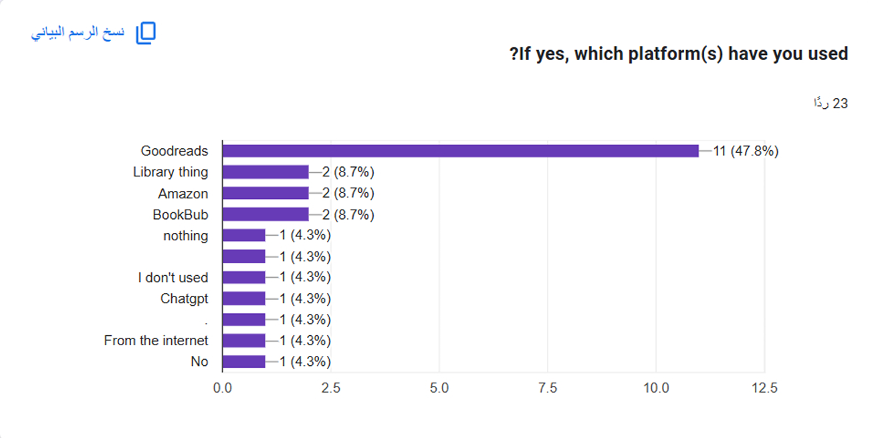
Figure 5 Questionnaires 4

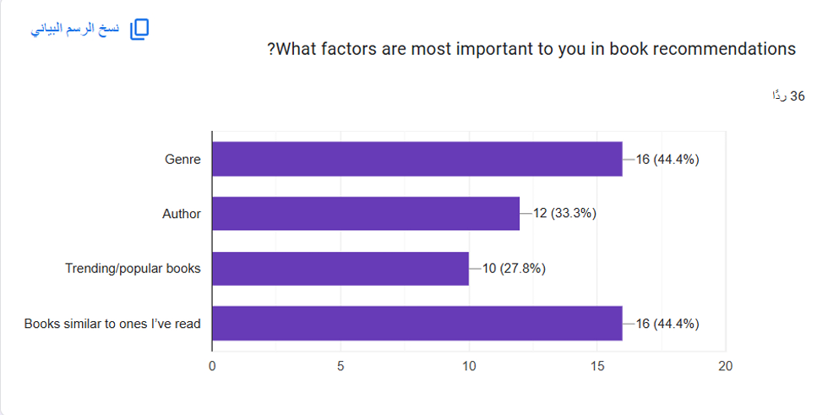
Figure 6Questionnaires 5

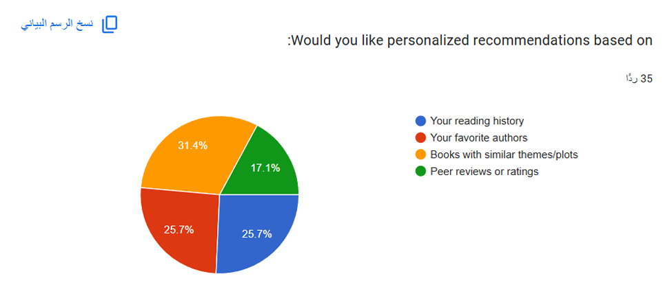
Figure 7Questionnaires6

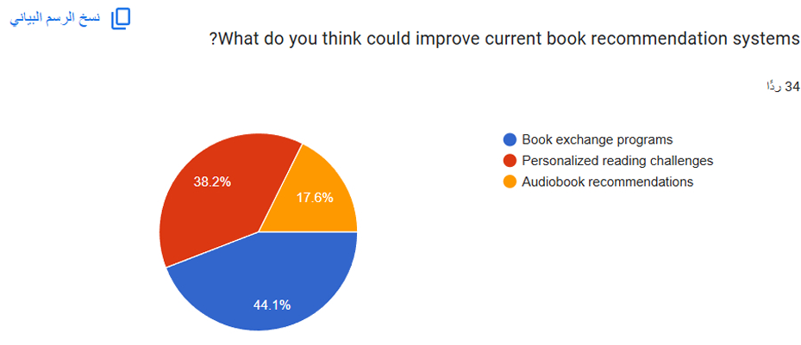
Figure 8Questionnaires7

3.3 The targeted users (Stakeholders)
The following are the primary stakeholders involved in the project:
- Readers:
- Role: Primary users of the system
- Interests:
  - Discover and rate books easily
  - Receive personalized book recommendations
  - Engage with reading communities
- University Instructors:
- Role: Content supervisors and academic promoters
- Interests:
  - Recommend educational books to students
  - Monitor student participation in reading activities
  - Use platform for academic purposes
- Developers:
- Role: Build and maintain the system
- Interests:
  - Implement features according to requirements
  - Ensure performance, scalability, and security
  - Maintain clean and maintainable code
- Library Staff:
- Role: Support integration with university library resources
- Interests:
  - Link library catalog with digital platform
  - Assist students with book access
  - Promote digital borrowing or referencing
- Authors
- Role: Create the content (books) may be featured in the recommendation system
- Interests:
  - view feedback and reviews to improve writing or promotion strategies
  - Track engagement data ( ratings, reading completion rates)
  - Grow their reader base and personal brand

3.4 functional requirements definition and specification
This table includes all main functional requirements with short description and notes for each one, all these functional requirements will be translated into use case diagrams after that the result use cases will be transformed into sequence diagrams with detailed description.
Table 10 functional requirements
FR | Name | Description
FR1 | Log-in | Filling in Email and Password blanks then the system will check if the email or password exist in the database then will be redirected to the role home page. If the password or the email is wrong an error will be appeared
FR2 | Log-out | By clicking on the logout button, the session will be destroyed, and the user will be redirected to the Log-in Page
FR3 | Sign up | the user is able to make a new account and sign in with it through the website
FR4 | Reset User Password | Any user can change his password, and the process will be as follows: The User will fill in the Username Data that will be email . Then The System will send email contain the link for update password link
FR5 | Change Password | The users can change their passwords by inserting their current password and their new password
FR6 | Change email | The users can change their email by inserting their current password and their new email
FR7 | Change username | The users can change their user user name by inserting there new user name
FR8 | Select preferences | The user will select 6 genre after register
FR9 | Write comment | The user can write comment on any book and share there opinion
FR10 | View comment | The user can view comments an any book
FR11 | Rating | The user cane submit rating for any book
FR12 | View rating | User can view community rating and API rating
FR13 | Random recommendation(from our reders) | Suggest random books from our readers contain comments and community rating
FR14 | Interact with Sliders | the user can clicks on the book sliders to view the book details
FR15 | Search engine | The user search about book by genre name author
FR16 | Upload user photo | The user cane upload photo or skip it
FR17 | Favorite list | The user can save or delete books from his profile the list stored in table in data base
FR18 | Library list | The user can save or delete books from his profile the list stored in table in data base
FR19 | Open cover list | The user can save or delete books from his profile the list stored in table in data base
FR20 | Closed cover list | The user can save or delete books from his profile the list stored in table in data base
FR21 | Dusty shelves | The user can save or delete books from his profile the list stored in table in data base

3.5 Non-functional requirements

This section outlines the non-functional requirements for the Next chapter system. These requirements define the system's qualities and constraints, ensuring that it operates efficiently, securely, and reliably under various conditions. Non-functional requirements are critical for achieving user satisfaction and meeting the overall goals of the system.
Table 11 Non-functional requirements
NFR | Name | Description
NFR1 | Performance | The system shall load book pages, reviews, and search results within 2–3 seconds under normal network conditions.  The Page transitions and UI animations will be rendered smoothly with minimal delay.
NFR2 | Usability | The interface shall be clean, responsive, and intuitive, using Bootstrap 5 and modern web design principles and graphics videos.  The system shall display clear error or success messages after login, registration, or submission failures.
NFR3 | Security | The system shall use SHA-256 to hash passwords before storing them in the database to protect against credential leaks.  The system shall enforce session-based access control.  All database queries shall use prepared statements to protect against SQL injection attacks.
NFR4 | Dependability | The system shall achieve 99% uptime during regular operation cycles.  Book status updates (favorite, read, wishlist) shall reflect immediately and remain consistent across pages.

3.6 Usability and user experience goals.

1.Responsive Design:
provide a responsive interface that adapts to various screen sizes (desktops, tablets, smartphones), ensuring that all functionalities are easily accessible regardless of the device used.
- Accessibility:
Ensure that the website is flexible and user-friendly for all stakeholders, taking into account their diverse backgrounds and needs.
- Error Handling and Feedback:
Offer clear, context-specific error messages and real-time feedback for actions such as form submissions, ensuring users can resolve issues efficiently.
- Consistency:
Maintain a consistent look and feel across all sections of the system, including user interfaces, buttons, and form layouts, to provide a cohesive user experience.
- Personalization:
  - Tailor the experience based on user preferences by providing relevant data and actions in dashboards, based what the like .

4.0 SYSTEM DESIGN

4.1 Architecture Design
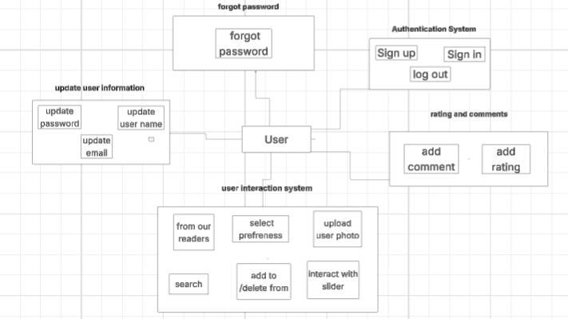
Figure 9 Architecture Design

4.2 Entity Relationship Diagram (ERD)

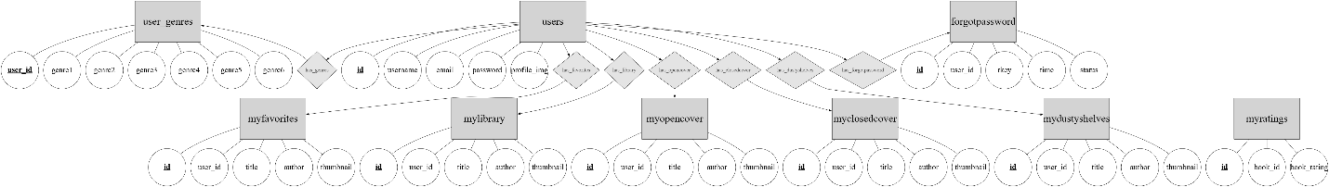
Figure 10 Entity Relationship Diagram (ERD)

4.3 Enhanced Entity Relationship Diagram

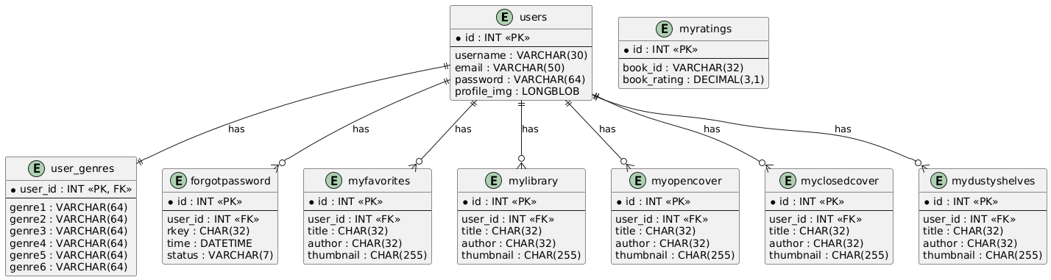
Figure 11 Enhanced Entity Relationship Diagram

4.4 UML Use Case Diagram
1-Authentication System:
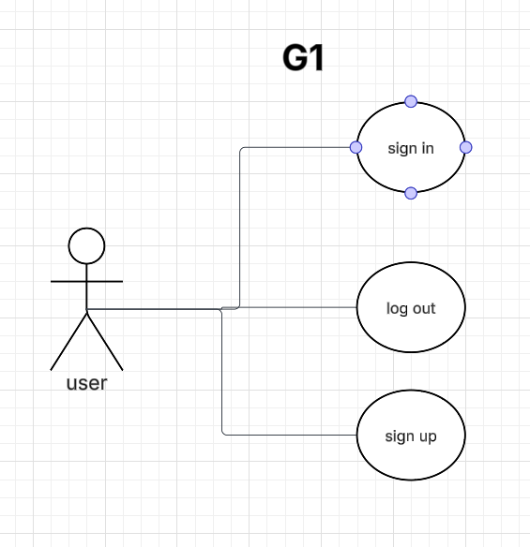
Figure 12 Use Case Diagram-Authentication system

2- forgot password
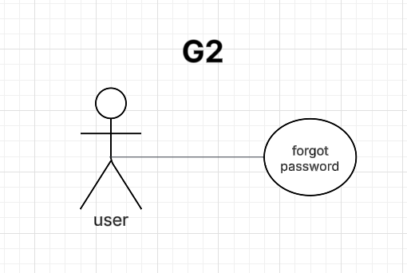

Figure 13Use Case Diagram-Forget password

3- update user information
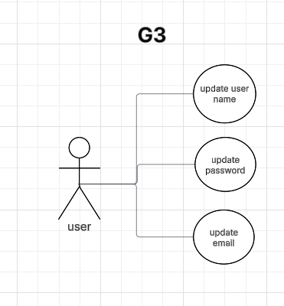
Figure 14 Use Case Diagram-update user information

4- rating and comments
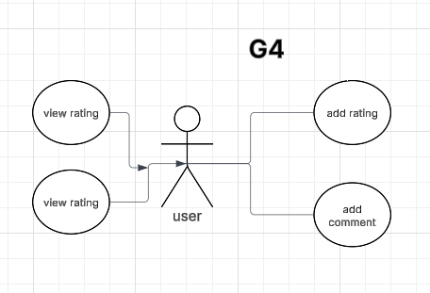
Figure 15 Use Case Diagram-Rating and comments

5- user interaction system

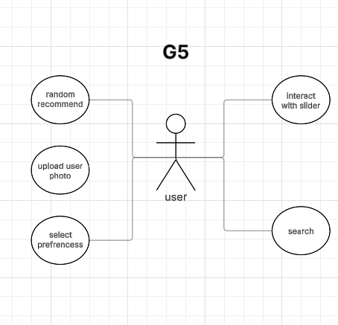
Figure 16Use Case Diagram-user interaction system

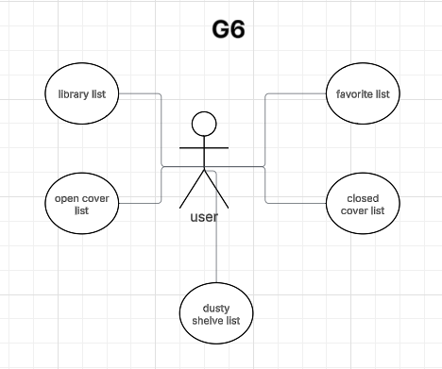

4.5 UML Sequence Diagram
G1: Authentication System:
Table 12 login sequence diagram
-login
Section | Details
Data | - User Name  - Email Address  - Password  - Error Message (if any)
Stimulus | - User inputs email and password  - User clicks on the “Login” button
Response | Success:  - User is authenticated  - System redirects to home/dashboard  - Welcome message is displayed  Failure:  - Error message shown (e.g., "Invalid email or password").
Scenarios | Scenario ST1: Successful Login  1. User enters valid email and password  2. System authenticates user  3. System redirects to dashboard  Scenario ST2: Failed Login  1. User enters incorrect credentials  2. System fails to authenticate  3. System shows error message
Comments | - Passwords are securely encrypted in the database

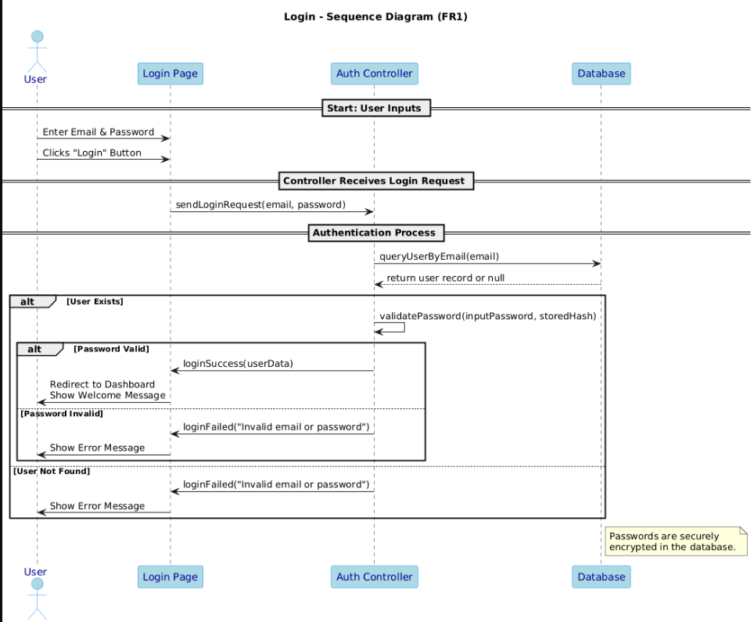
Figure 17 login-Sequence Diagram(FR1)

-signup
Table 13 signup sequence diagram
Section | Details
Data | - User Name  - Email Address  - Password  - Error Message (if any)
Stimulus | - Guest clicks on “Register”  - Inputs name, email, and password  - Clicks “Submit”
Response | Success:  - Account is created  - User is redirected to the login page  - Success message displayed  Failure:  - System shows error (e.g., "Email already in use" or "Invalid input")
Scenarios | ST1: Successful Registration  1. Guest inputs valid name, email, and password  2. System checks for email duplication  3. System creates account  4. Redirect to login  ST2: Failed Registration  1. Guest inputs email already used  2. System rejects registration  3. Error message shown
Comments | - Passwords are stored using secure encryption

Table 14 Register-Sequence Diagram (FR2)
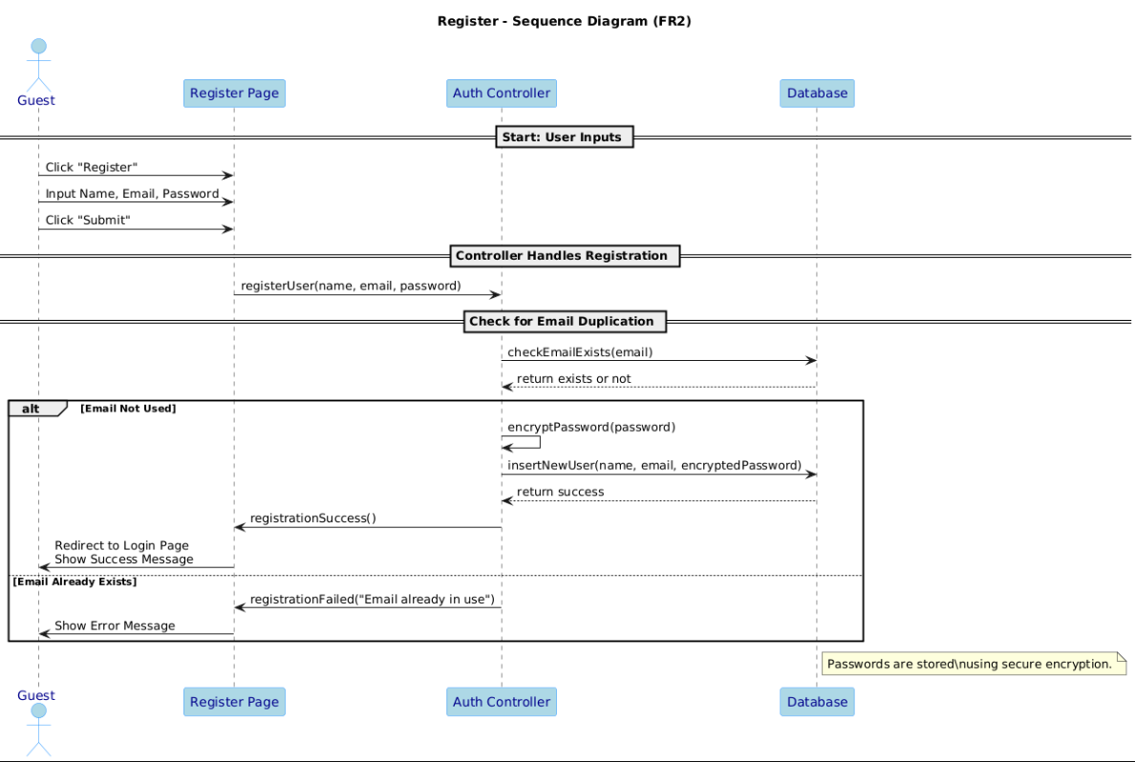

-log out
Table 15 logout
Data | - Log Out Button
Stimulus | User clicks the “Logout” button
Response | Success:  – Session is terminated  – User is redirected to the login page  – Message: "Logged out successfully"  Failure:  – (Optional) Error if session termination fails
Scenarios | ST1: Successful Logout  1. User clicks "Logout"  2. System clears session/cookie  3. Redirects to login page  ST2: Session Not Found  1. Session expired/corrupted  2. System detects invalid session  3. Redirects to login with optional error
Comments

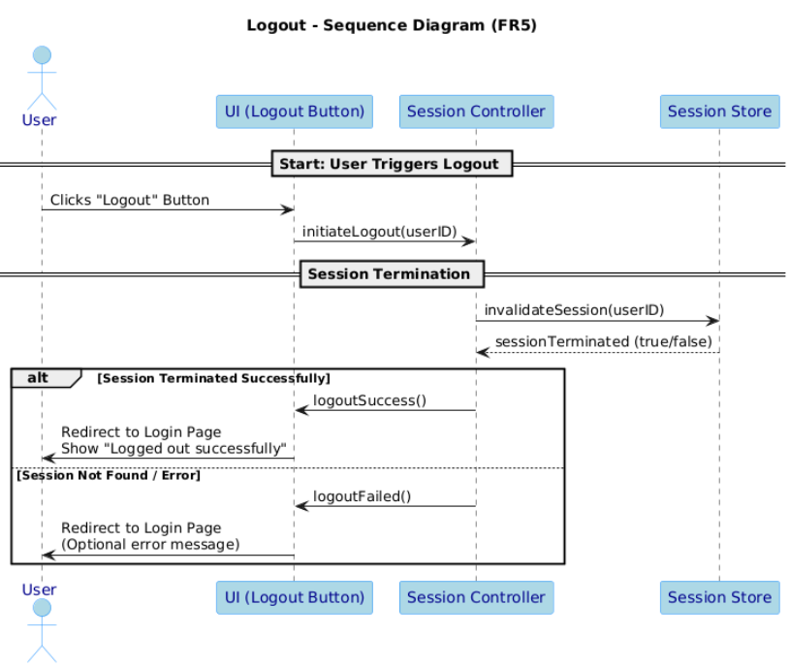
Figure 18 Logout -Sequence Diaram (FR5)

G2: forgot password
Table 16 forgot password
Data | - Email Address  - Reset Link  - New Password  - Error Message (if any)
Stimulus | - User clicks on "Sign In"  - Clicks "Forgot Password"  - Enters email and submits  - Clicks reset link in email  - Enters new password & submits
Response | Success:  – Session is terminated  – User is redirected to the login page  – Message: "Logged out successfully"  Failure:  – (Optional) Error if session termination fails
Scenarios | ST1: Successful Password Reset  1. User requests password reset with a valid email  2. System verifies email  3. Reset link sent  4. User clicks link and sets new password  5. Password updated and redirected to login  ST2: Invalid Email Submission  1. User enters email not in system  2. System shows error  ST3: Reset Failure  1. User opens expired or invalid reset link  2. System denies reset and shows message
Comments | - Email is verified against the database  - Reset links are sent securely  - Passwords are hashed before storing  - User is redirected post-reset

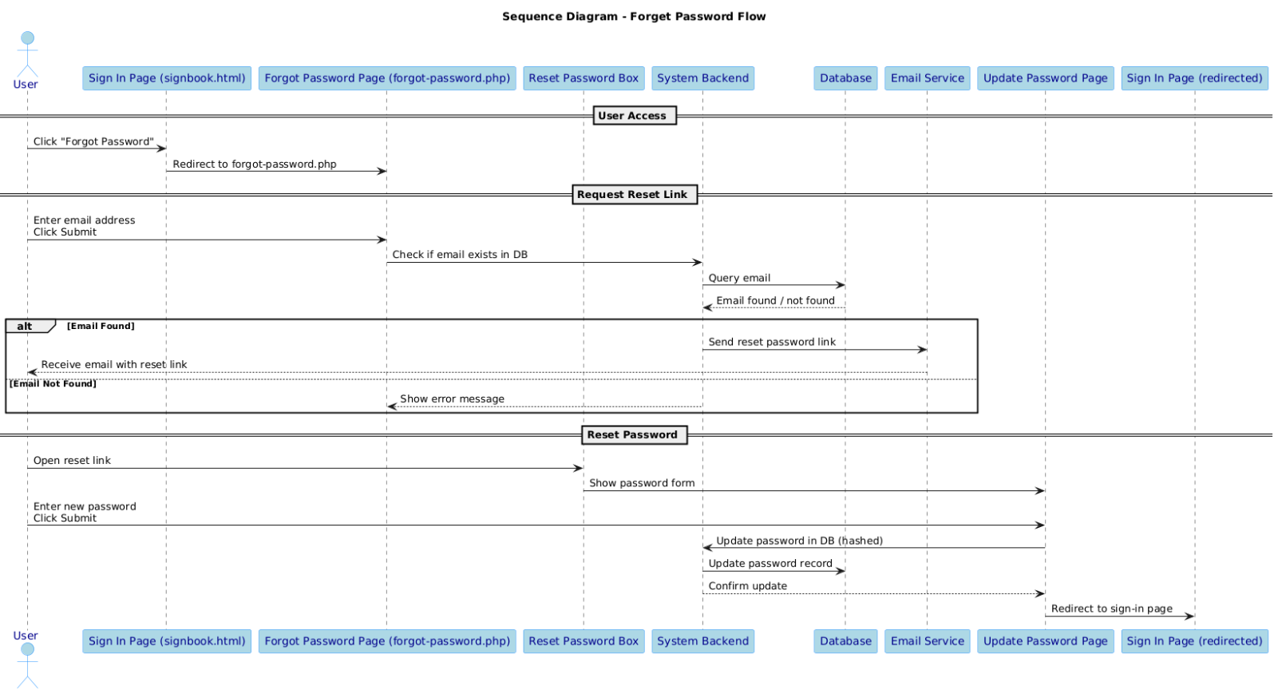
Figure 19 Sequence Diagram-forget password flow

G3: update user information
-update user name
Table 17 update user name
Data | - New User Name  - Success/Failure Message
Stimulus | - Logged-in user navigates to profile/settings  - Edits the username field  - Clicks "Update"
Response | Success:  - System validates input  - Updates username in the database  - Displays success message  Failure:  - System shows error if username is invalid, empty
Scenarios | ST1: Successful Username Update  1. User enters a new valid username  2. System updates record  3. Success message displayed  ST3: Invalid Input  1. User enters an empty or invalid username  2. System displays input validation error
Comments | - Username must meet validation rules (e.g., min/max length, allowed characters)

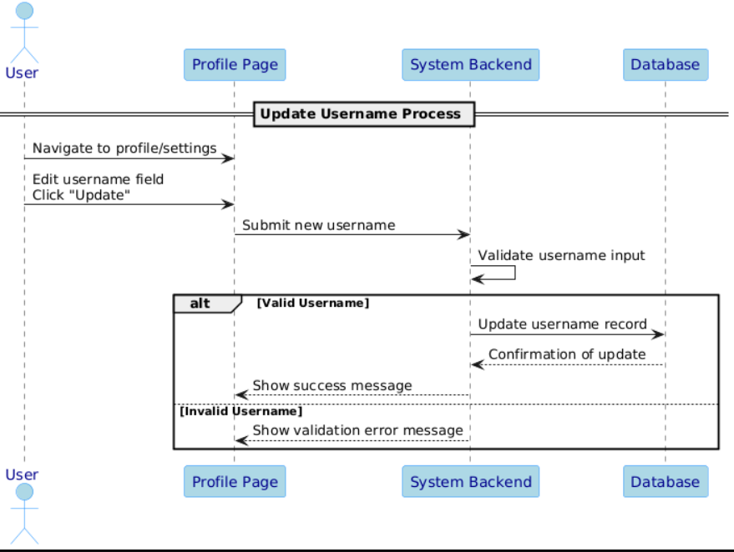
Figure 20Sequence Diagram-Update UserName

-update email
Table 18 update email
Data | - New email  - Success/Failure Message
Stimulus | - Logged-in user navigates to profile/settings  - Edits email field  - Clicks "Update"
Response | Success:  - System validates input  - Updates email in the database  - Displays success message  Failure:  System shows error if email is invalid, empty, or already in use
Scenarios | ST1: Successful Username Update  1. User enters a new valid email  2. System checks for uniqueness  3. System updates record  4. Success message displayed  ST2: Duplicate Username  1. User enters a email that already exists  2. System rejects update  3. Error message shown  ST3: Invalid Input  1. User enters an empty or invalid email  2. System displays input validation error
Comments | -email must meet validation rules (e.g., min/max length, allowed characters)
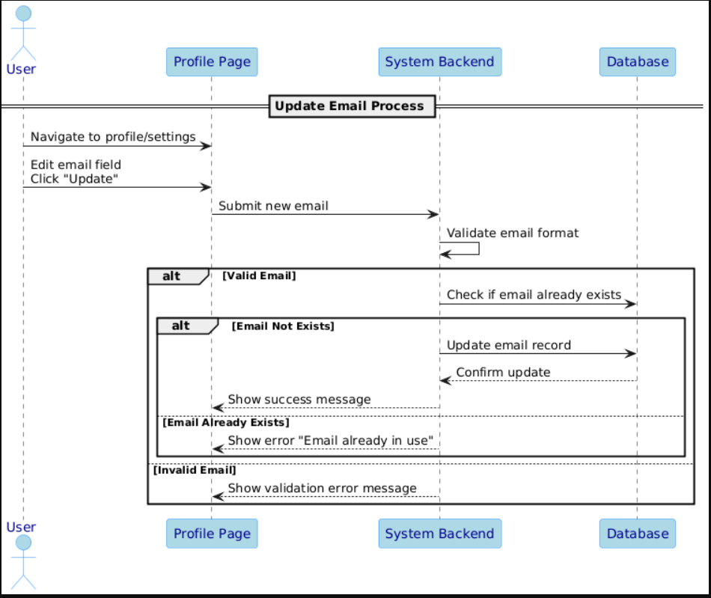
Figure 21Sequence Diagram-Update Email

-update password
Table 19 update password
Data | - New password  - Success/Failure Message
Stimulus | - Logged-in user navigates to profile/settings  - Edits password field  - Clicks "Update"
Response | Success:  - System validates input  - Updates hash password in the database  - Displays success message
Scenarios | ST1: Successful Username Update  1. User enters a new valid password  3. System updates record  4. Success message displayed  ST2: Invalid Input  1. User enters an empty or invalid password  2. System displays input validation error
Comments | -password must meet validation rules (e.g., min/max length, allowed characters)

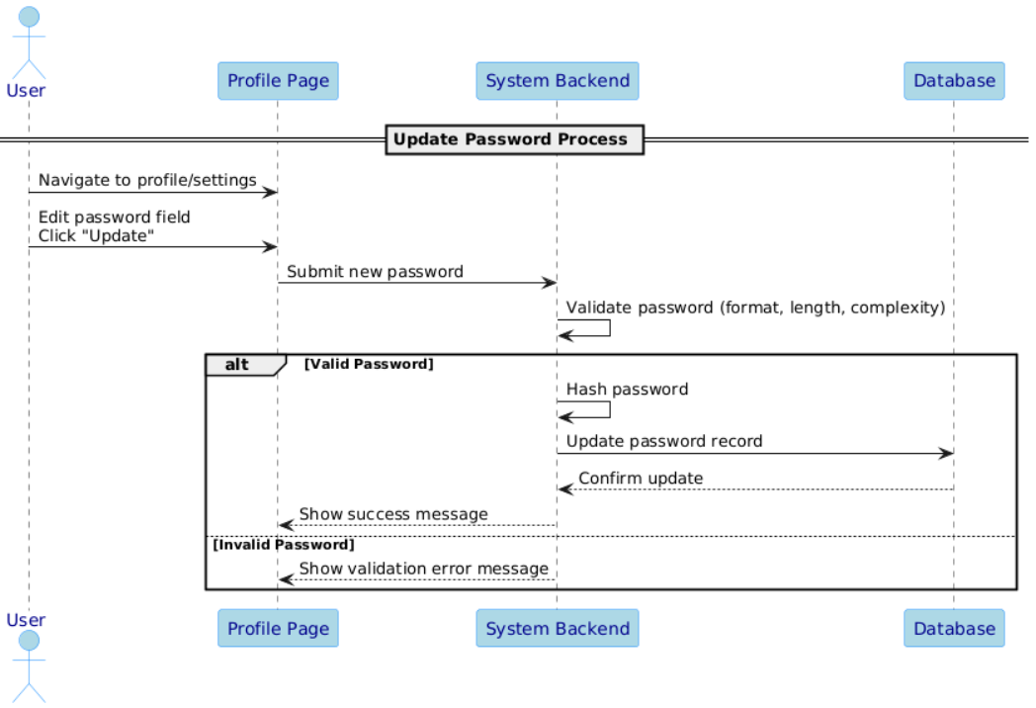
Figure 22Sequence Diagram-Update Password

G4: rating and comments
-add rating
Table 20 rating
Data | - User ID  - Book ID  - Rating Value  - Average Rating  - Success Message
Stimulus | - User fill stars with rating  - User submit rating button
Response | - System checks for existing rating  - Inserts or updates rating record  - Recalculates average rating  - Shows success message to user
Scenarios | ST1: New Rating  1. User submits a rating for a book they haven’t rated before  2. System inserts new rating  3. Confirms and shows success  ST2: Update Existing Rating  1. User submits a new rating for a book they’ve already rated  2. System recalculates the average  3. Updates record  4. Shows success
Comments | - Rating is tied to specific user and book IDs  - UI updates the user review section to reflect the new rating immediately

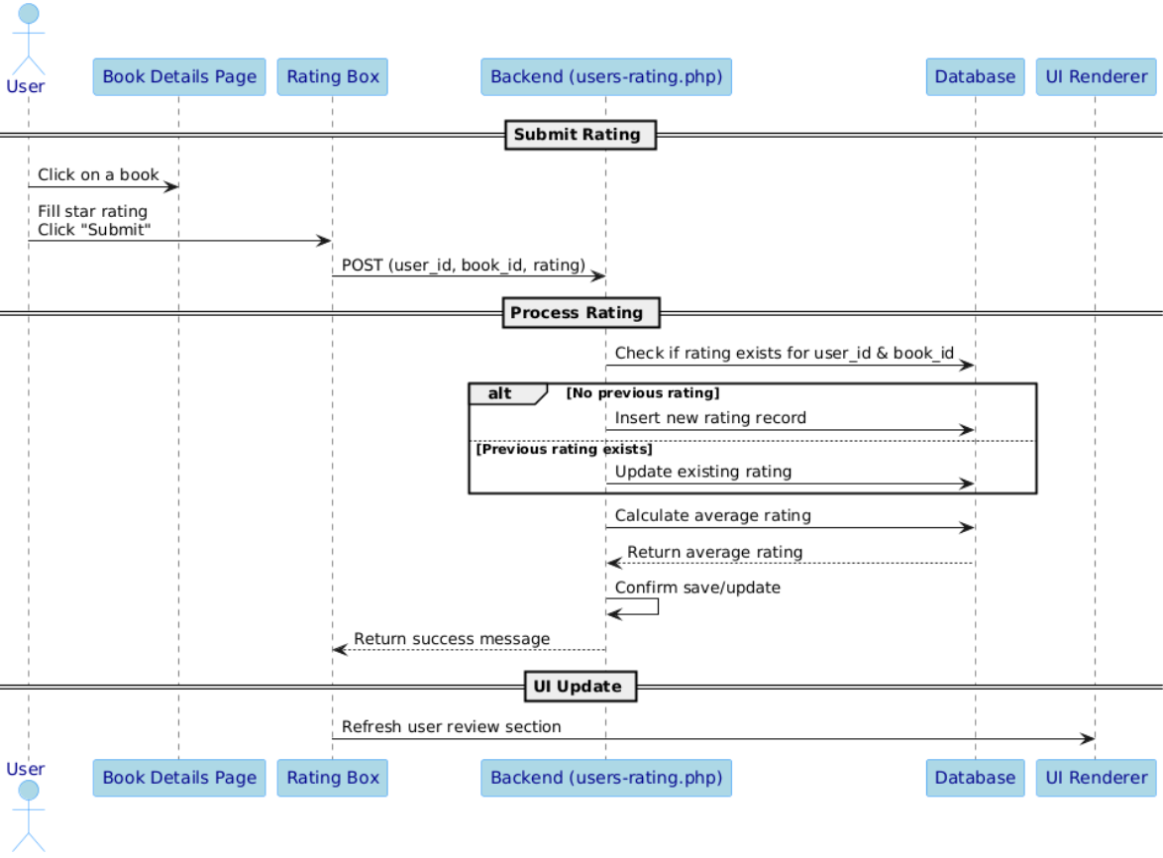
Figure 23Sequence Diagram-rating

-view rating
Data | - User ID  - Book ID  - Rating Value  - Average Rating
Stimulus | - User click on any book  - system display 2 type of rating (API rating , community rating)
Response | - System checks for existing rating  - display rating record according to book id for community rating  - display rating from API according to book id for API rating
Scenarios | ST1: display Rating  1. User click on book doesn’t have rating in community  2. System display 0.0 rating by default  ST2: Update Existing Rating  1. User click on book doesn’t have rating in API  2 System display 0.0 rating by default
Comments

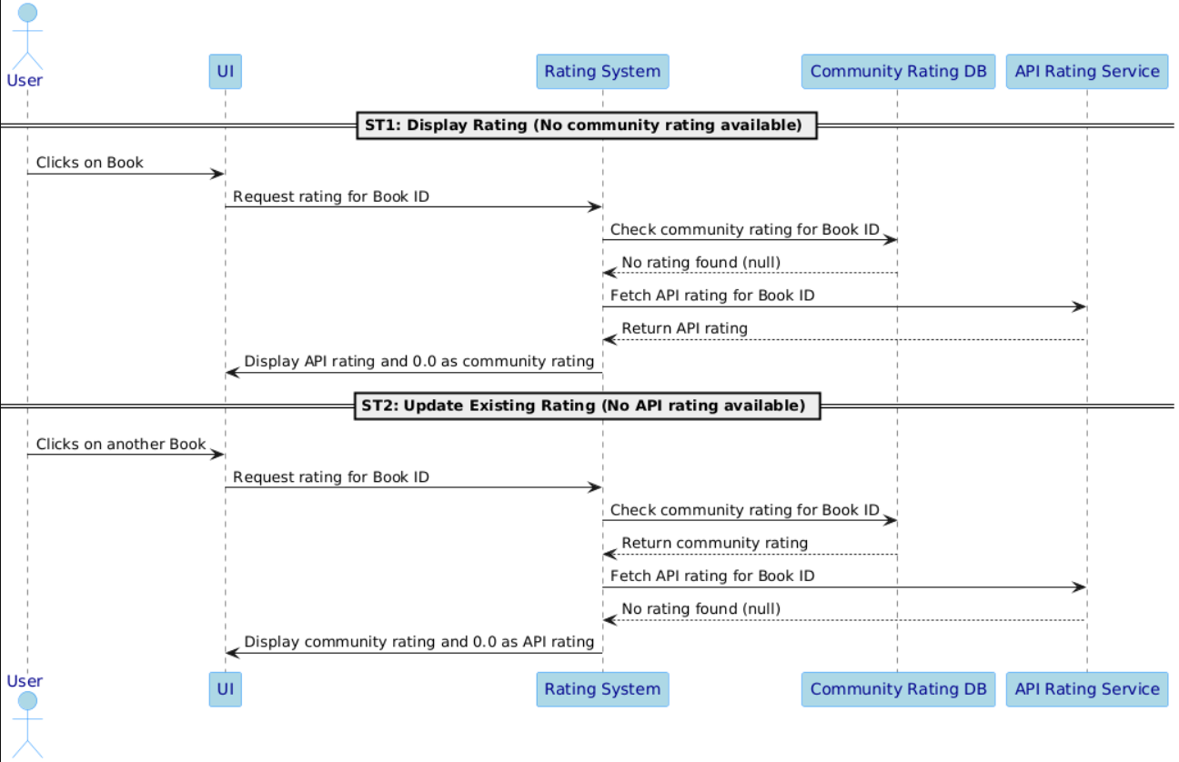

-comments
Table 21 comments
Data | - User ID  - Book ID  - Rating Value  - Average Rating  - Success Message
Stimulus | - User write comment  - User submit rating button
Response | - System filters the comment for offensive content  - Saves it  - Returns a success response  - UI updates the review section
Scenarios | ST1: Valid Comment  1. User writes an appropriate comment  2. System filters bad words and replace it with ***  3. Comment is saved  4. Success message shown  5. UI is updated
Comments | - Comment filtering is essential to prevent abusive/offensive content  - Immediate UI update enhances user experience

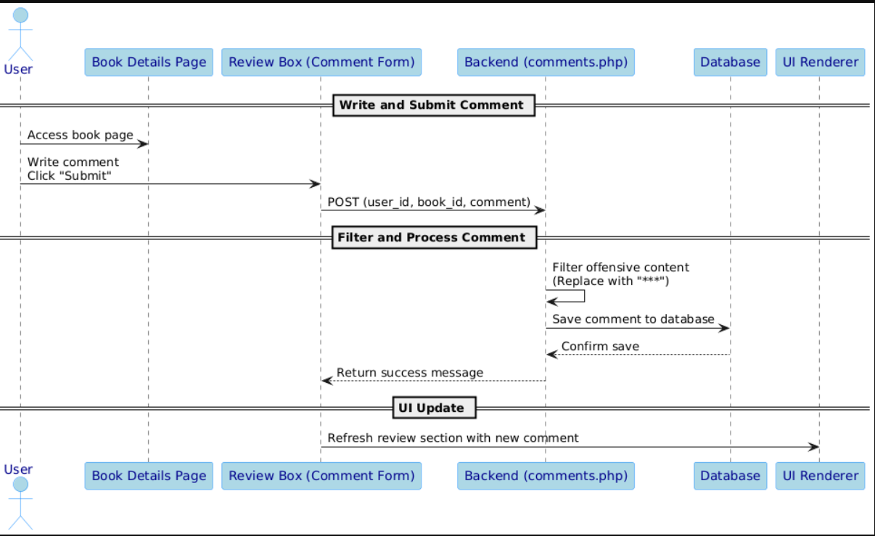
Figure 24 Sequence Diagram-

-comments
Data | - User ID  - Book ID  - comments
Stimulus | - User click on any book  -display comment under the book in comments section
Response | - System checks for existing comments  - display comments
Scenarios | ST1: display comments  1. User click on book doesn’t have comments in community  2. System doesn’t display comments section
Comments

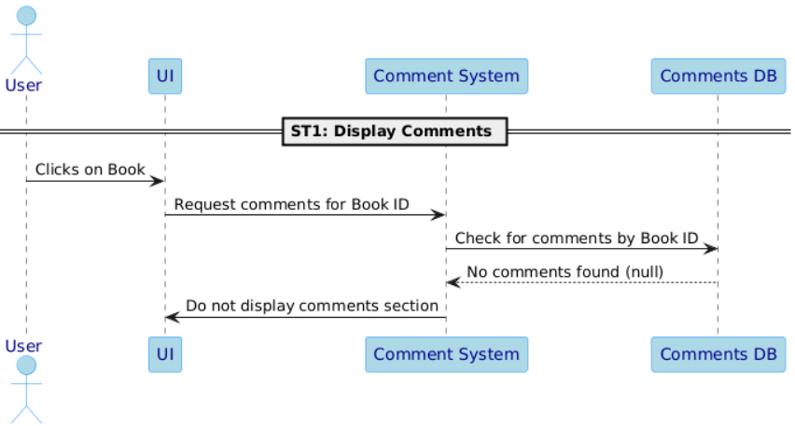

G5: user interaction system
Table 22 button interaction
Data | - User ID  - Book ID  - Book status  - list type  - Success Message
Stimulus | -User clicks an action button to add or remove a book from a list (Favorites, Library, one cover , closed cover , dusty shelve.)
Response | - System checks if book is already in the list  - Sends appropriate request (add/remove) to backend  - Updates database  - Returns success/failure message  - UI reloads the updated page
Scenarios | ST1: Add New Book to List  1. User clicks an action button  2. System checks list and finds book not present  3. Book is added to the list in the database  4. Success message returned  5. UI reloads with updated info  ST2: Remove Book from List  1. User clicks an action button  2. System finds the book is already on the list  3. Book is removed from the list in the database  4. Success message returned  5. UI reloads with updated info
Comments | - Efficient checking avoids duplicate list entries  - UI reload ensures updated list is visible  - Separation of backend services improves maintainability

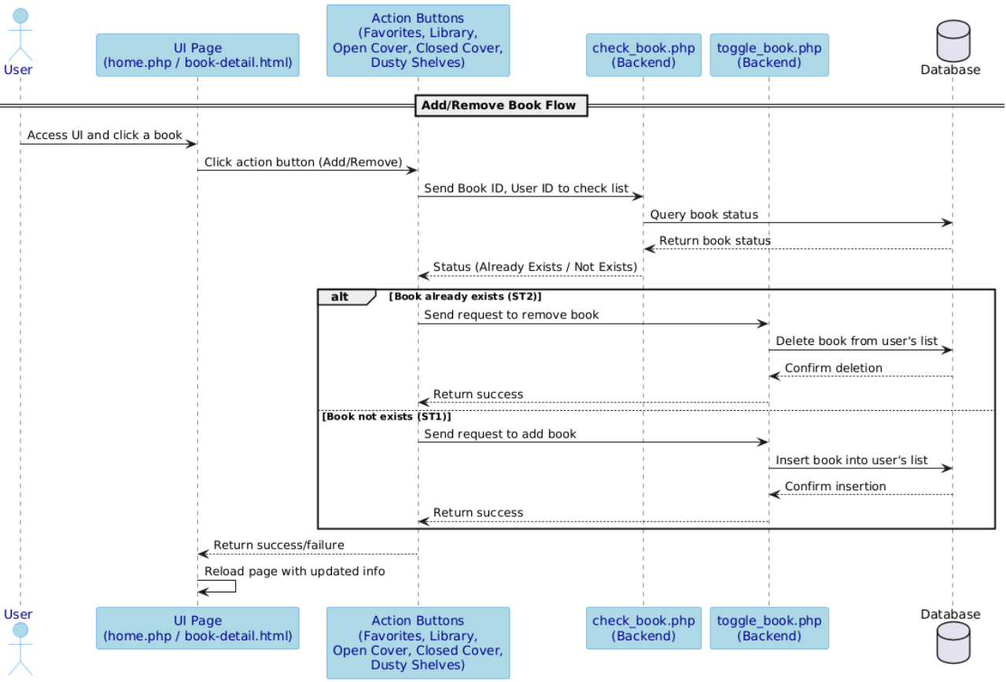
Figure 25 Sequence Diagram-button interaction

-select genre
Table 23 select genre
Data | - User ID  - Selected Genres (Preferences)
Stimulus | - User visits the preferences page after signing up  - Selects only 6 genres and clicks "Continue"
Response | - System saves selected genres by user_id  - Redirects to the Upload Photo page
Scenarios | ST1: Successful Genre Selection  1. User visits the preferences page  2. User selects genre checkboxes  3. Clicks "Continue"  4. System receives and saves preferences  5. Confirms data saved  6. Redirects to photo upload page
Comments | - Selecting preferences improves personalization  - Saving preferences at this step ensures continuity in profile setup  - Immediate redirect helps streamline onboarding flow

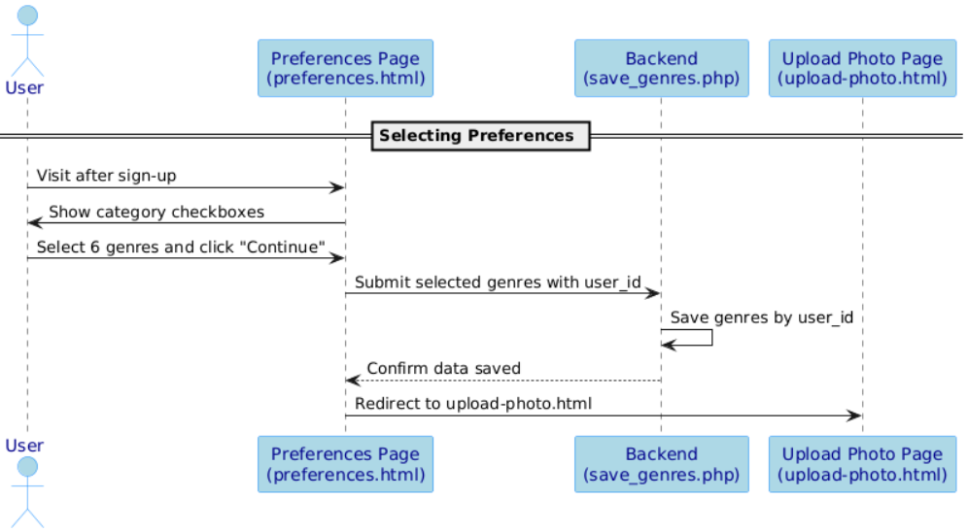
Figure 26 Sequence Diagram-select genre

-upload user photo
Table 24 upload photo
Data | - User ID  - Uploaded Image
Stimulus | - User uploads an image from the upload photo page  - user can skip upload and system will chose default photo
Response | - System uploads image to cloud storage  - Receives and returns image URL  - Saves the photo URL to database using user_id  - Redirects user to the home page
Scenarios | ST1: Successful Photo Upload  1. User visits upload photo page  2. Uploads an image  3. System sends image to cloud storage  4. Cloud returns image URL  5. System saves image URL using user_id  6. Confirms photo saved  7. Redirects user to home page
Comments | - Cloud storage ensures scalability and efficiency  - Using a URL instead of raw image data in the database improves performance  - Redirecting to the homepage finalizes the onboarding process smoothly

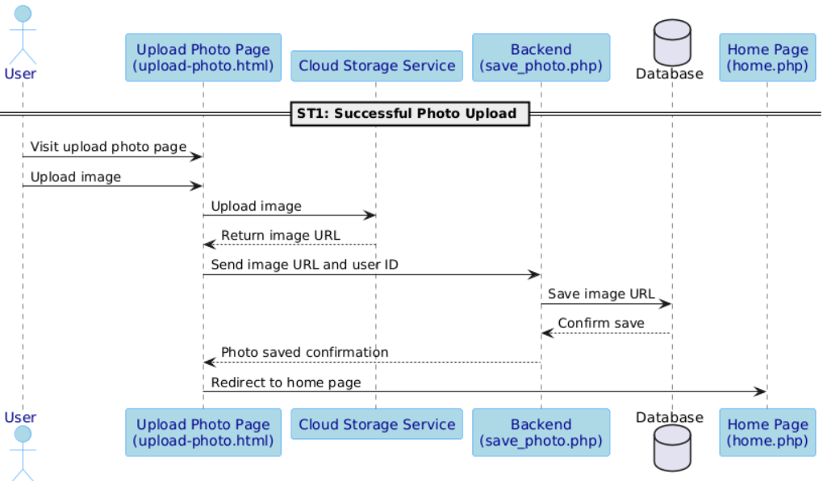
Figure 27 Sequence Diagram upload user photo

Table 25 search bar
Data | - Search Keyword (Book Metadata (title, author, cover, category))
Stimulus | - User enters a keyword in the search bar  - User clicks on a book card from the search results
Response | - System triggers a search request to the Google Books API  - Returns a list of matching books in JSON  - Renders book cards with title, cover, rating  - On selection, navigates to detail view  - Fetches full book metadata and displays details
Scenarios | ST1: Book Search and View Details  1. User enters a search keyword  2. System triggers API call with query  3. Matching book list is returned in JSON  4. Book cards are rendered in the UI  5. User clicks on a specific book  6. System requests full metadata for that book  7. Book detail page is loaded with complete info
Comments | - Using Google Books API ensures a rich external dataset  - Rendering partial metadata helps user explore options quickly  - Full metadata fetch on-demand improves efficiency and performance

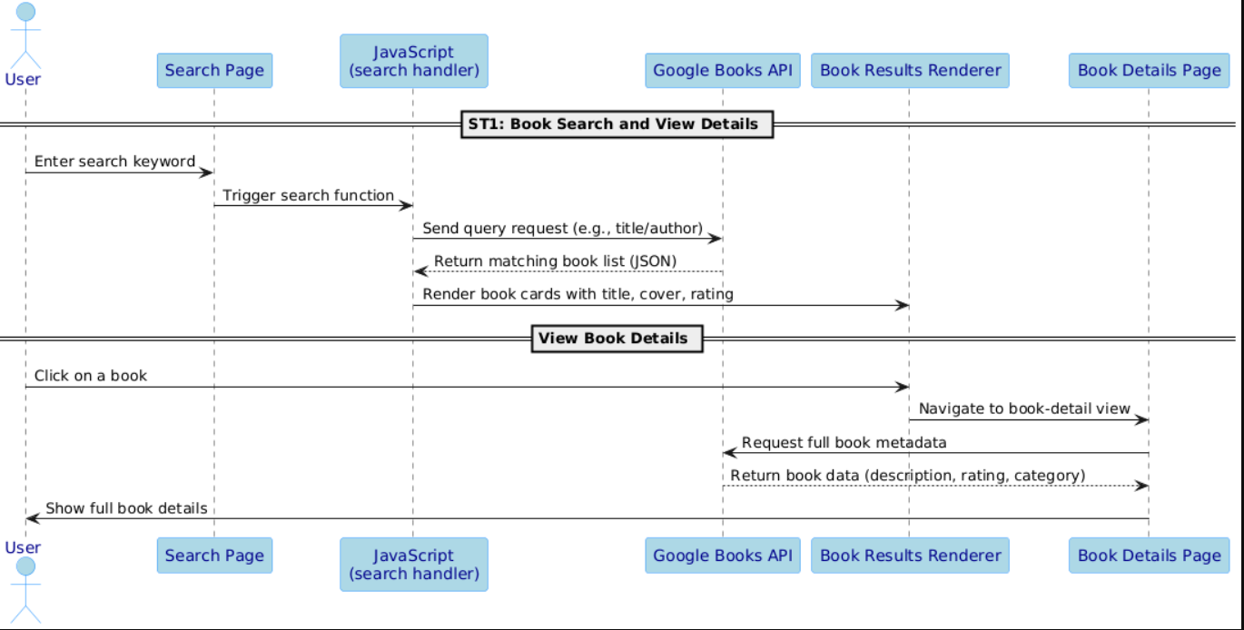
Figure 28 Sequence Diagram search engine

Table 26 random recommendation
Data | - Book id  -User_name  -Book rating from our readers  -comments from our readers
Stimulus | - User lands on the home or suggestion section  - User clicks an arrow button to view a new random suggestion
Response | - System queries the database for books with user ratings and comments  - Randomly selects one book from the result set  - Displays the book with title, cover, rating, and a highlighted comment  - On user interaction (arrow click), fetches another random suggestion
Scenarios | ST1: Initial Suggestion Load  1. User visits home/suggestion area  2. System fetches list of books with comments and ratings  3. Random book is selected and shown  ST2: View Another Suggestion  1. User clicks the next suggestion arrow  2. System fetches another random book from the filtered list  3. Displays the new suggestion
Comments | - Promotes user engagement by showing crowd-endorsed content  - Random selection avoids repetition and increases discovery

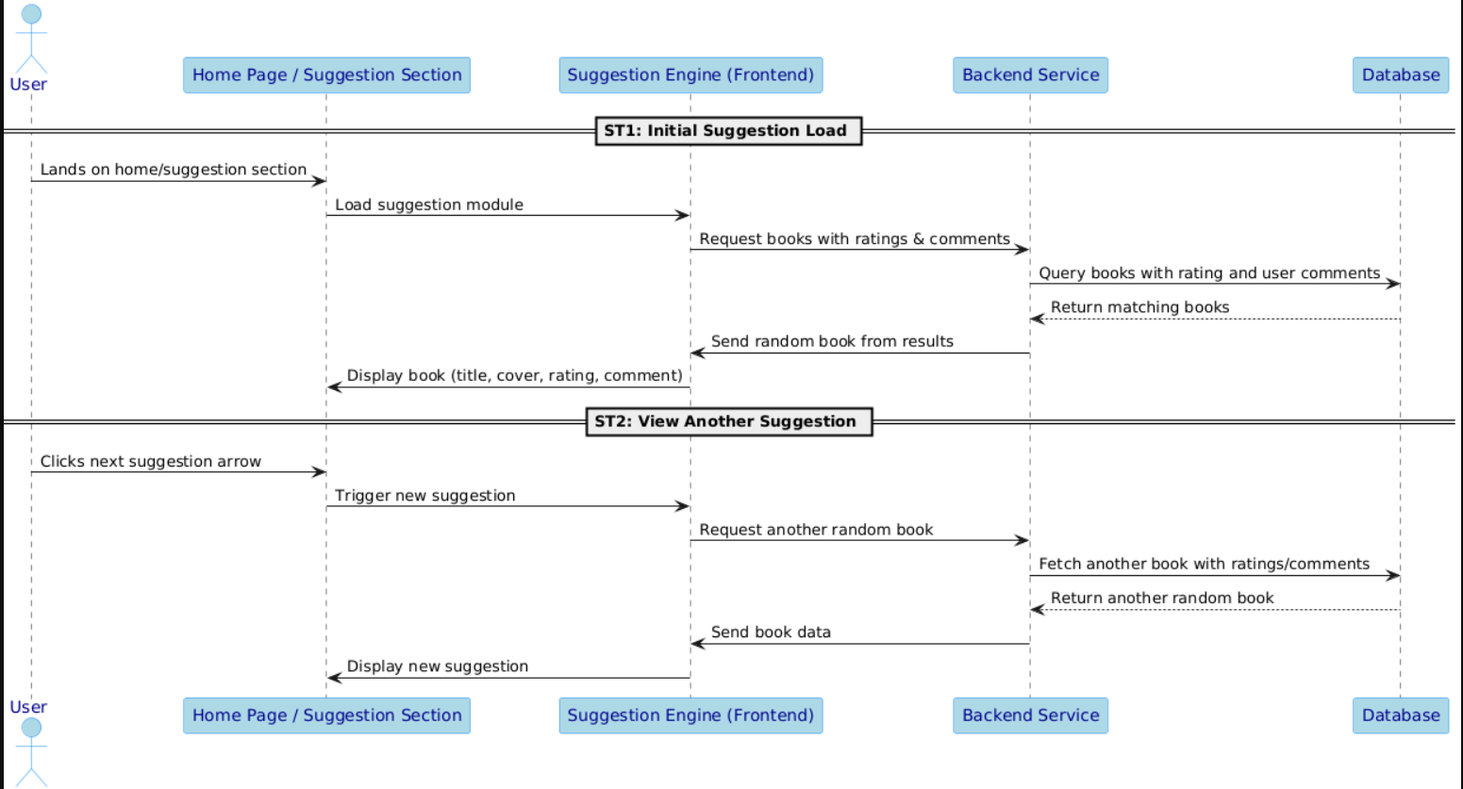
Figure 29 Sequence Diagram randomr recommendation

Book details
Table 27 book details
Data | - Book id  -User_name  -Book Metadata  - A lot of actions Type
Stimulus | - User browses the homepage slider  - Clicks on a book to view more details  - Can interacts with any action buttons
Response | - System navigates to book detail view  - Fetches and displays full metadata of the book  - On button click, sends request to backend  - Updates user's list (add/remove)
Scenarios | ST1: View Book from Slider  1. User clicks a book in the slider  2. System navigates to the book details page  3. Full metadata is retrieved and shown  ST2: Interact with any action Button  1. System checks book's presence in the list  2. Sends add/remove request to backend  3. Updates database  4. Returns confirmation and updates button state
Comments | - Slider encourages discovery through visual engagement  - Quick interactions increase personalization  - Seamless navigation from slider to details enhances user experience

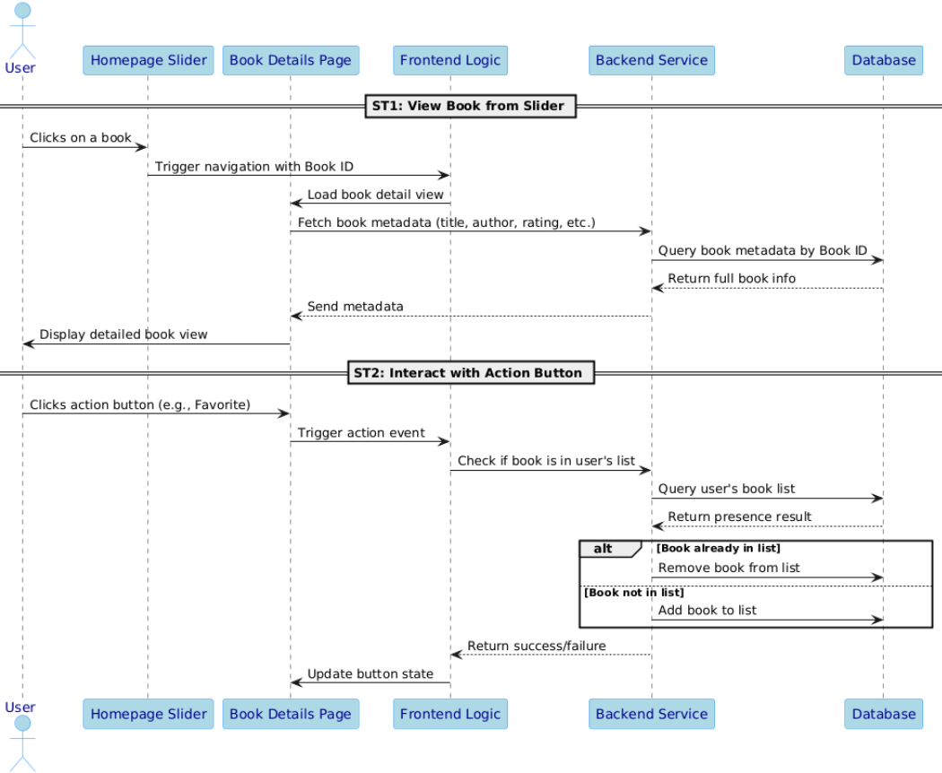
Figure 30 Sequence Diagram book details

G6 : the 5 list
Data | - Book id  -User_name  -Book Metadata  - A lot of actions Type
Stimulus | - User browses the homepage slider  - Clicks on a book to view more details  - Can interacts with any action buttons
Response | - System navigates to book detail view  - Fetches and displays full metadata of the book  - On button click, sends request to backend  - Updates user's list (add/remove)
Scenarios | ST1: View Book from Slider  1. User clicks a book in the slider  2. System navigates to the book details page  3. Full metadata is retrieved and shown  ST2: Interact with any action Button  1. System checks book's presence in the list  2. Sends add/remove request to backend  3. Updates database  4. Returns confirmation and updates button state
Comments | - Slider encourages discovery through visual engagement  - Quick interactions increase personalization  - Seamless navigation from slider to details enhances user experience

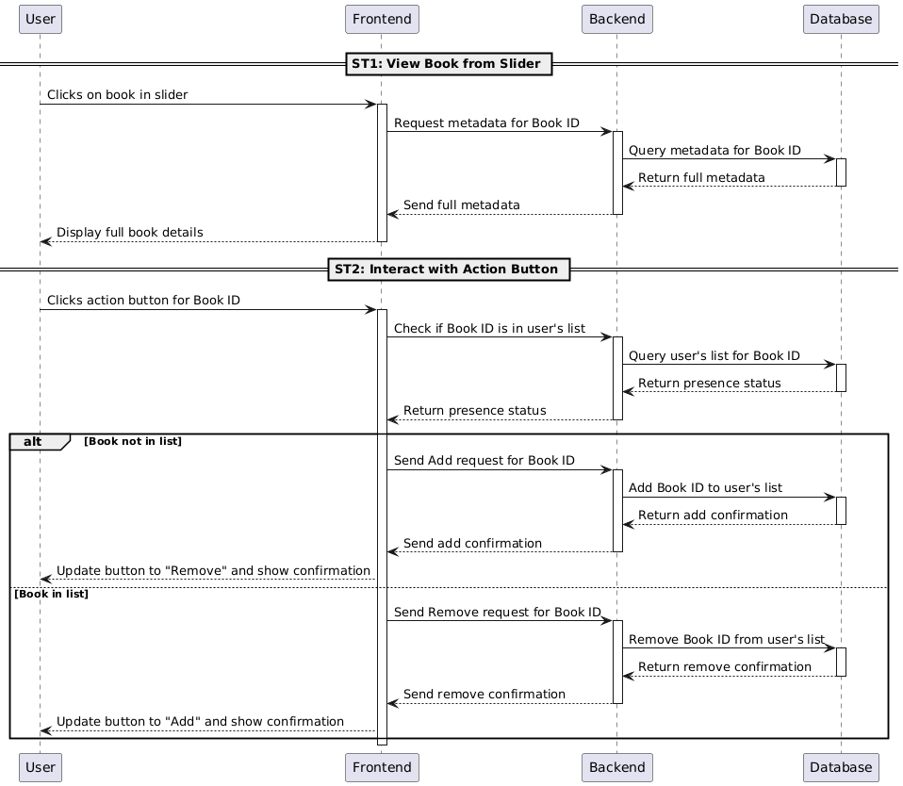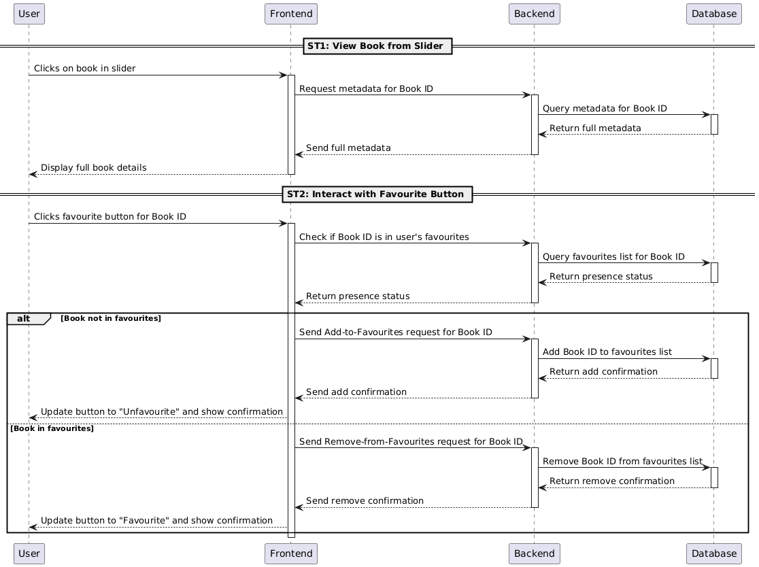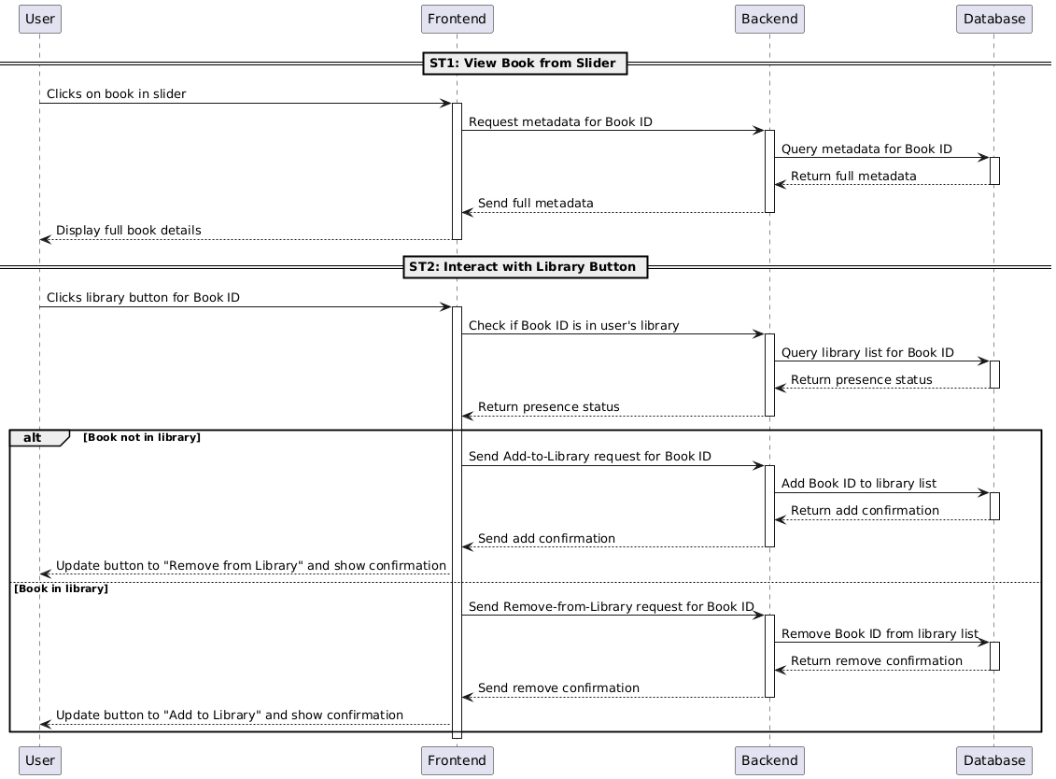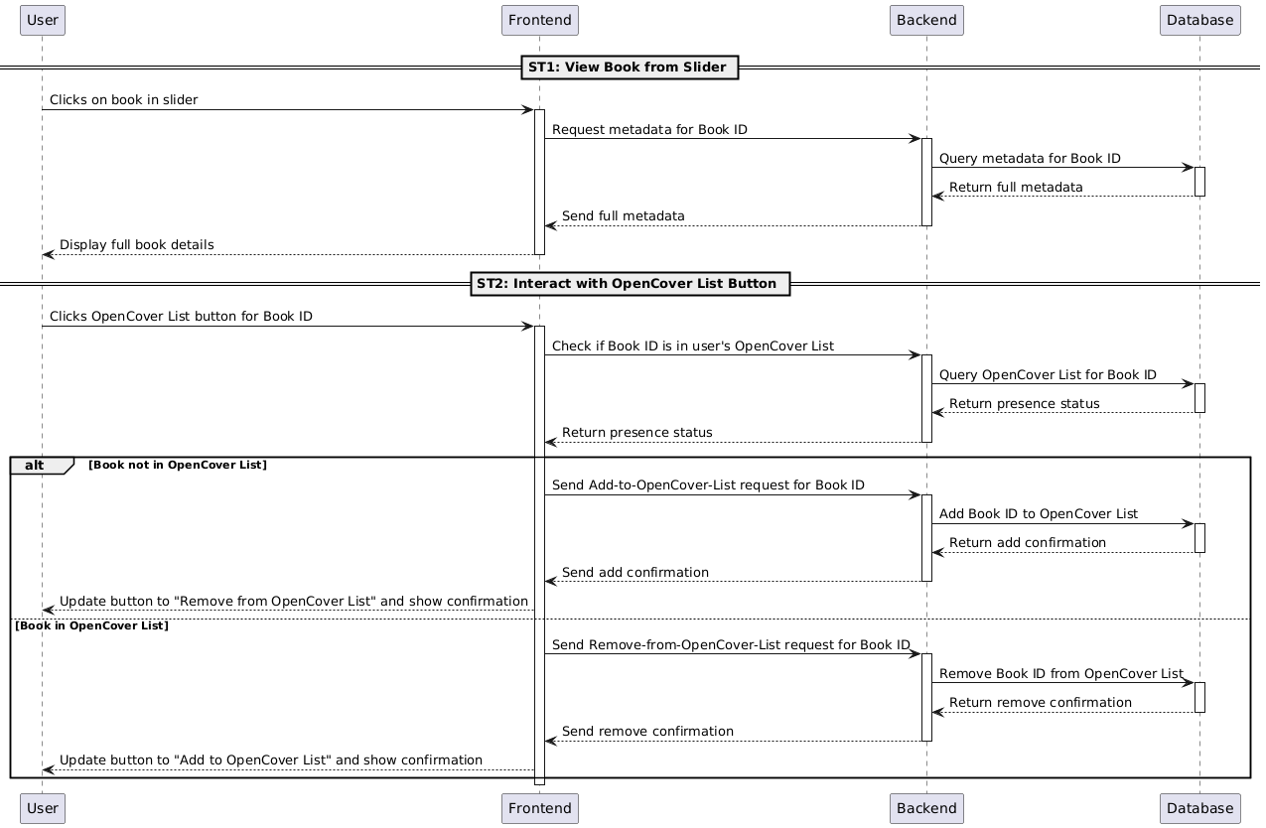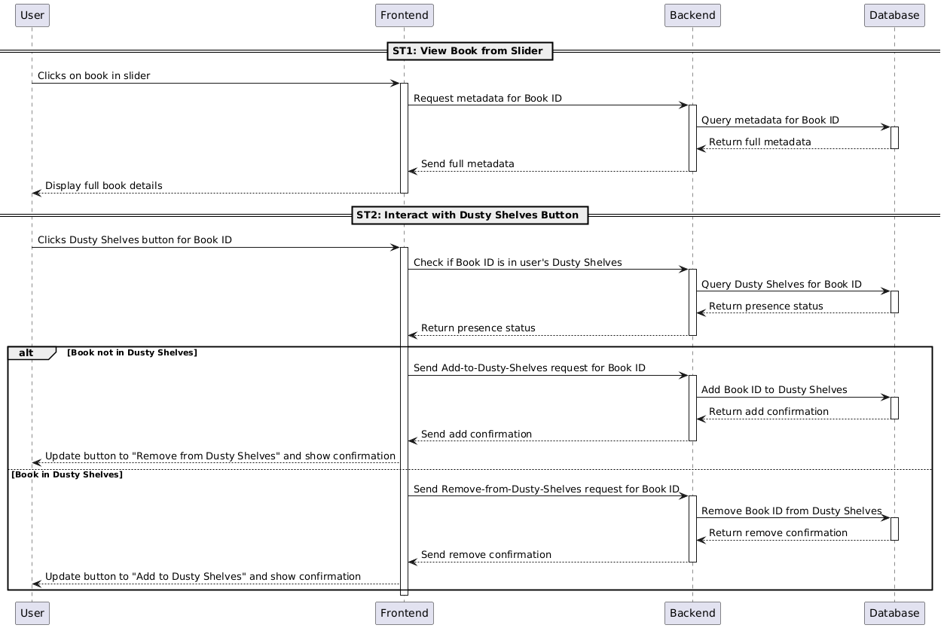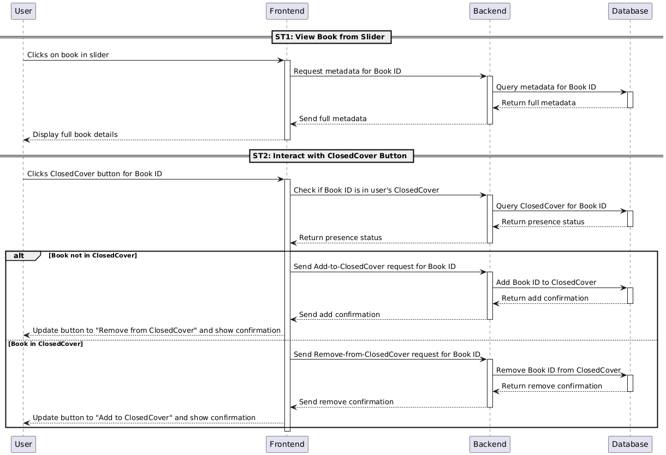

4.6 Database Design

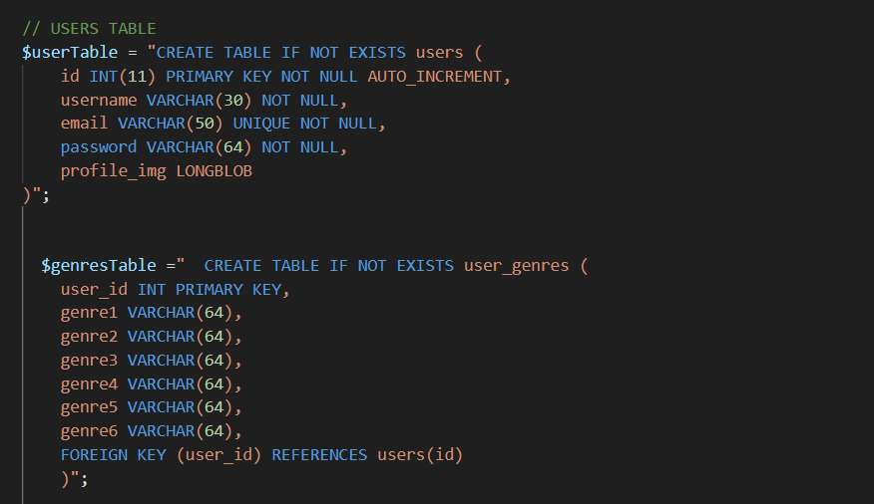
Figure 31 Database Design

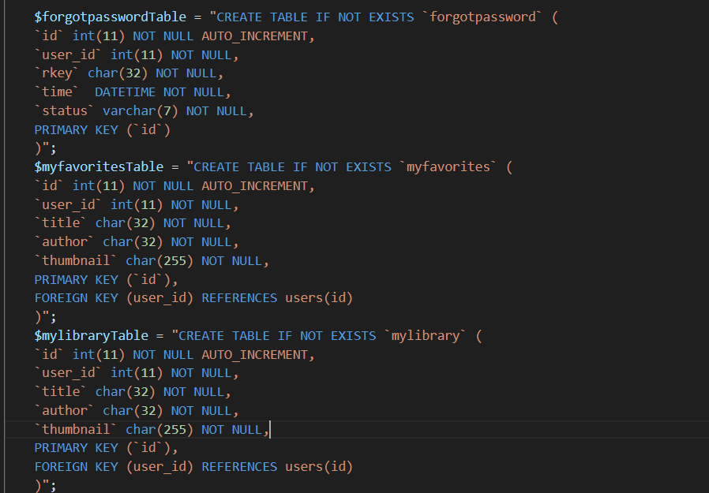
Figure 32 Database Design 2

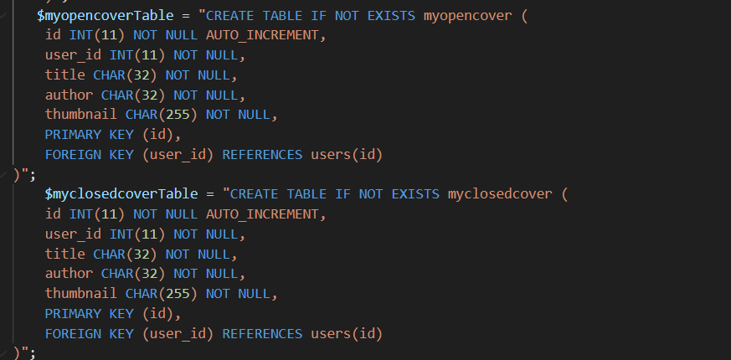
Figure 33 Database Design 3

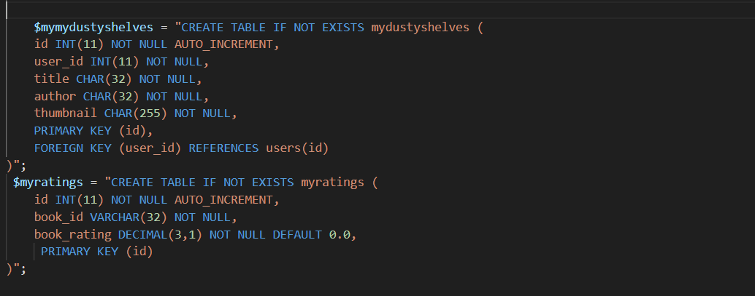
Figure 34 Database Design 4

5.0 PROJECT IMPLEMENTATION

5.1 Implementation requirements

The project was developed using PHP for backend development, leveraging core PHP for authentication, database interactions, and API integrations, with selective use of Laravel components (PHPMailer) for email services. The frontend was built using HTML5, CSS3 (Bootstrap 5), and JavaScript to ensure a responsive, interactive interface, enhanced by Blender and After Effects for animated transitions. MySQL, hosted on Railway, served as the database system, managed via Railway’s dashboard for seamless deployment and scalability. External data was fetched via the Google Books API, with client-side JavaScript handling dynamic content to reduce server load. Git/GitHub facilitated version control and collaborative development.
Data base hosted on railway change url for hosting then run create_tables.php

6.0 SYSTEM TESTING AND INSTALLATION

This chapter presents the system testing and installation aspects including the heuristic evaluation, cooperative evaluation, system installation, and user manual. It also describes the manual and automated testing approaches used to validate the system’s functionality and performance.

6.1 Testing

1. Unit Testing (Manual): Each fuction and button was tested independently to validate the internal logic and verify that each unit produced the expected output for given inputs.
2. Integration Testing (Manual): After unit testing, related modules were combined and tested to ensure smooth data flow and proper interaction between components.
3. System Testing (Manual): The fully integrated system was tested as a whole to confirm that all specified functional requirements were met across the platform.
4. End-to-End Testing (Manual): Real-world scenarios were tested from the user’s perspective, simulating complete workflows to ensure the system functioned as expected from start to finish
5. Stress Testing (Performance Testing) (Automated with Postman): Finally, stress testing was conducted using Postman to simulate high-volume concurrent API requests. This tested the system’s responsiveness and stability under load, identifying any performance bottlenecks.

6.2 Heuristic Evaluation
Evaluation Method:
- Two usability experts evaluated the system’s web interface using Jakob Nielsen’s 10 usability heuristics.
- Each issue was categorized under a heuristic and given a severity rating from 0 (not a problem) to 4 (critical problem).
Summary of Violations by Heuristic:
- H1: 4 (7.5%), H2: 3 (5.6%), H3: 6 (11.3%), H4: 8 (15.1%), H5: 5 (9.4%)
- H6: 4 (7.5%), H7: 6 (11.3%), H8: 5 (9.4%), H9: 4 (7.5%), H10: 8 (15.1%)
Severity Ratings:
- Severity 0: 10 (18.8%)
- Severity 1: 9 (16.9%)
- Severity 2: 12 (22.6%)
- Severity 3: 11 (20.7%)
- Severity 4: 11 (20.7%)
Key Findings:
- Issues included inconsistent button styling, lack of tooltips, and absence of user guidance.
- Recommendations: Unify design components, add help icons/tooltips, and clarify form validations.

6.3 Cooperative Evaluation
Participants:
- users
Tasks and Observations:
- Login and Registration: All users found registration smooth and intuitive.
- Search & Save Book: Users were able to search and add books to favorites with no errors.
- Rate and Review: Posting comments was successful; suggested preview for posted reviews.

Table 28 Tasks and Observations:
Task | Avg time | Feedback summary
Register and login | 30sec | Smooth flow; clear errors
Search and press all buttons | 2.5 min | Easy to use; liked real-time display
View interactions and reviews | 1 min | Suggested moderation filters for reviews

6.4 System Installation
Installation Requirements:
- Hosting: XAMPP / localhost
- Database: Mysql hosted on Railway
- Backend: PHP 8.0+
- Frontend: HTML, CSS, JavaScript, Bootstrap 5
Installation Steps:
- Extract project files into htdocs directory (if using XAMPP).
- Create data base on railway then put url in connection.php then run create_tables.php(you can read readme.txt from repository ).
- Start Apache .
- Access the system via http://localhost/Graduation-project/index.html
Tested Environments:
- Browsers: Chrome, Firefox, Edge
- Devices: Desktop
- Loading Time: <2 seconds for all major functions

6.5 User Manual
Nextchapter is a book recommendation and review platform designed to help users discover and organize their reading journey. This manual provides user guidance across all available features.

Figure 35 First page 1
This figure is the first page in our website

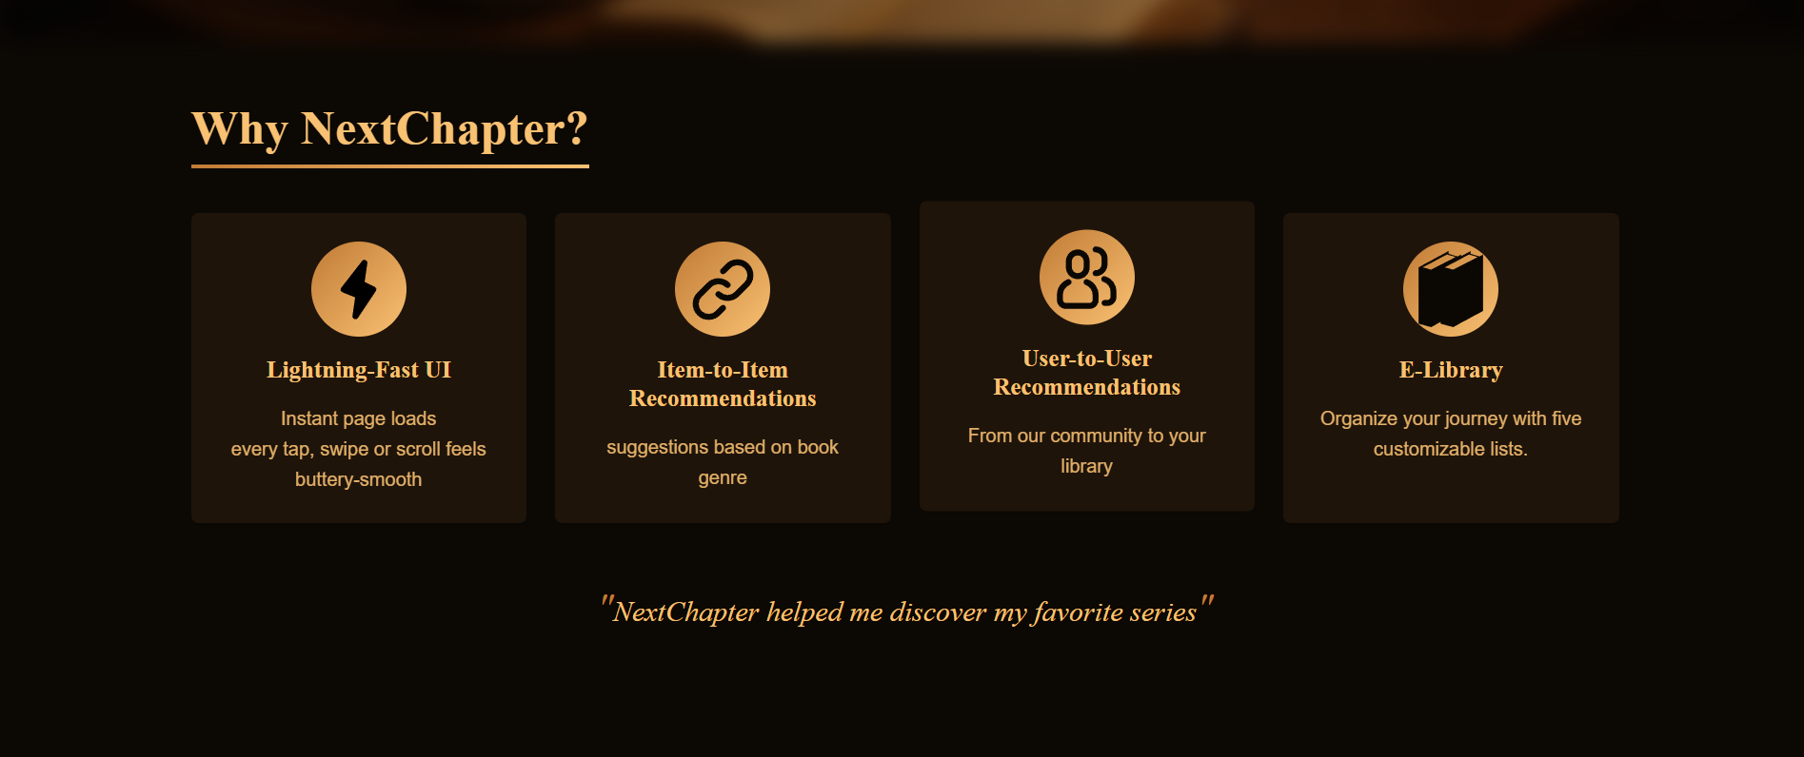
Figure 36 First page 2
This figure shows why next chapter

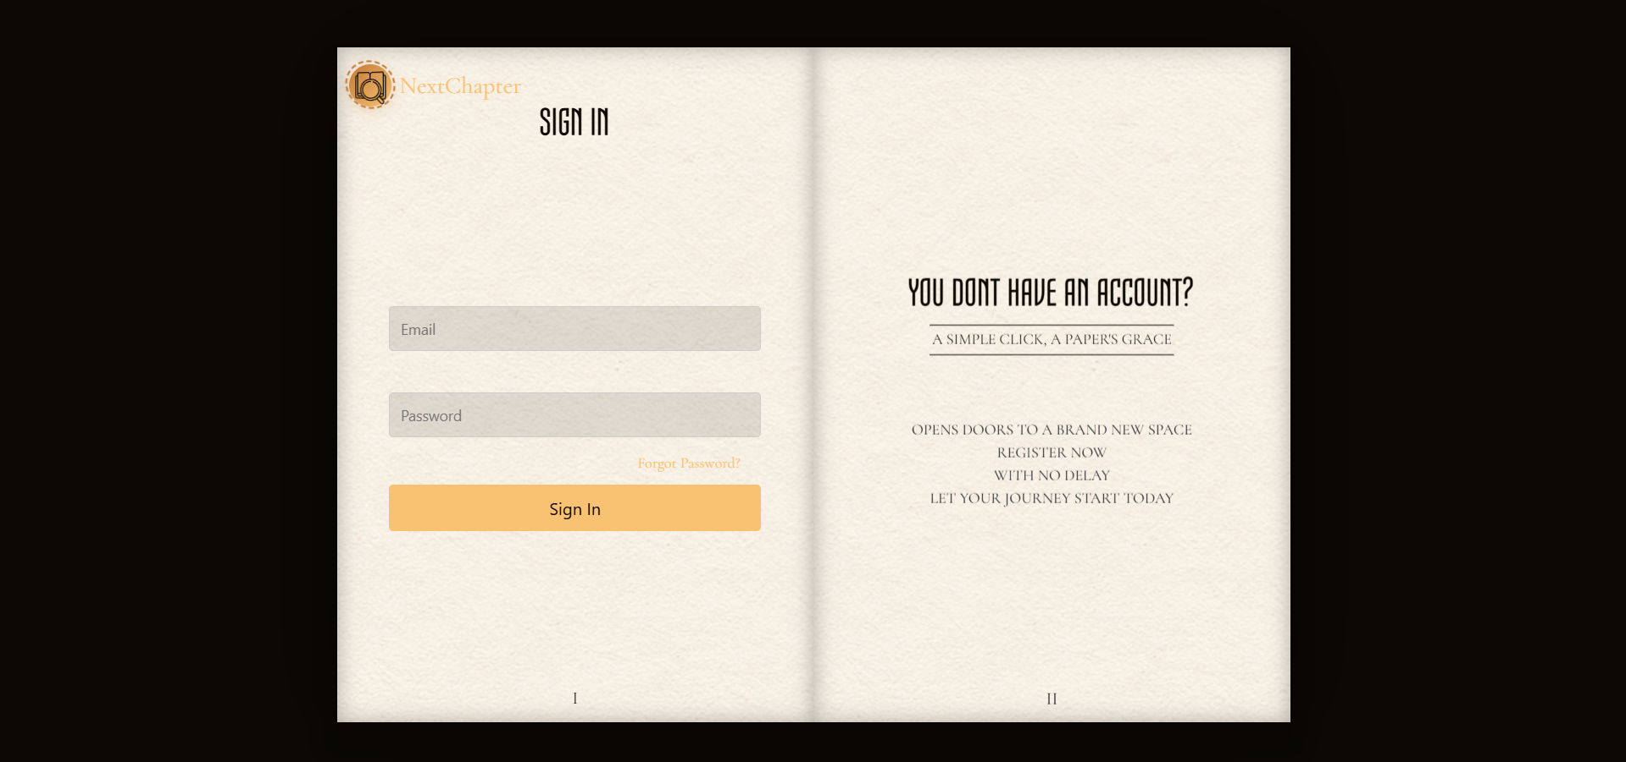
Figure 37 sign in page
This figure shows sign in page user enter email and password to sign in
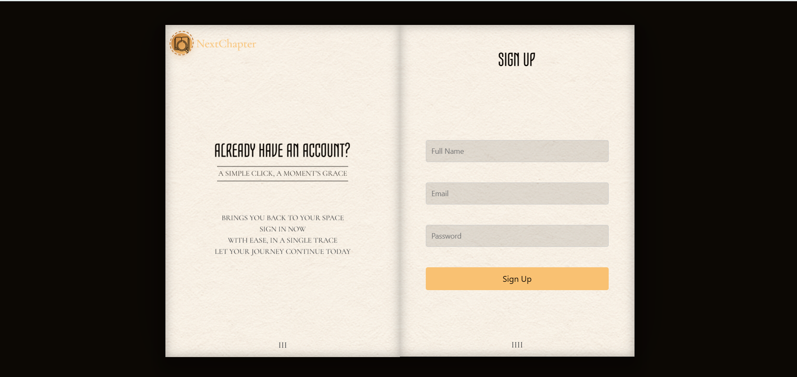
Figure 38 sign up page
This figure shows signup page use will enter full name and unique email and password


Figure 39 prefrances page
This figure shows the genre that user can store in data base
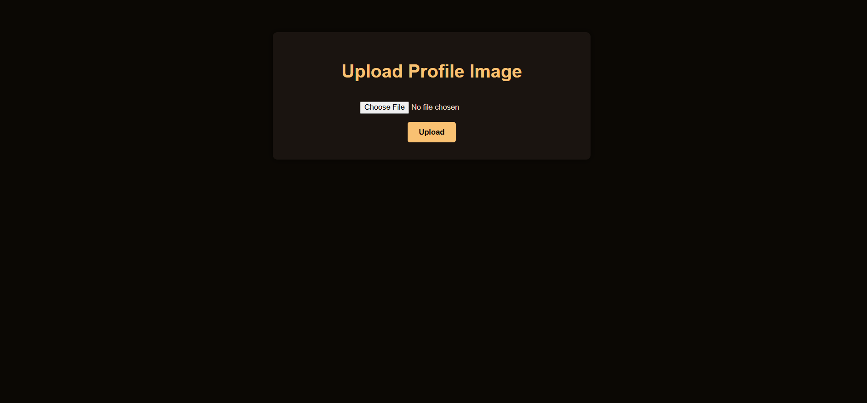
Figure 40uploade pfp
This figure shows upload user photo

Figure 41 home page 1
This figure shows welcome video in home page
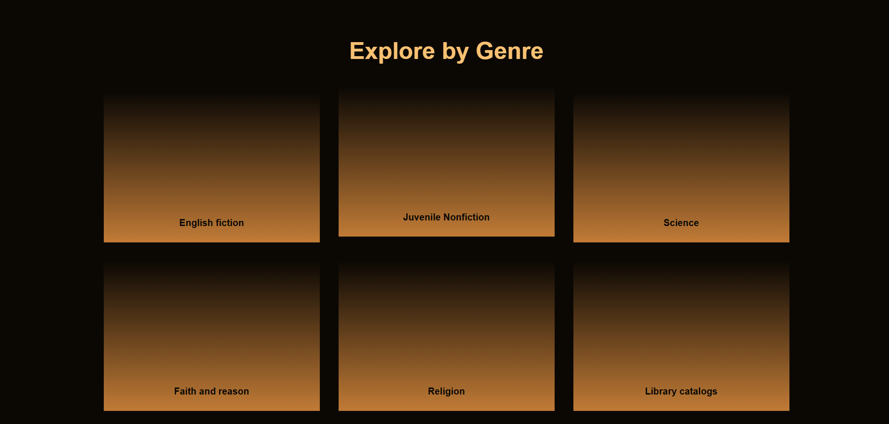
Figure 42 home page 2
This figure shows genre section that user stored in data base


Figure 43 home page 3
This figure shows suggested slider

Figure 44 home page 4
This figure shows random recommendations from our user


Figure 45 Recommendation page 1
This figure show search engin

Figure 46 Recommendation page 2
This figure show list of book genre that user store in data base


Figure 47 about page
From blinder video show about next chapter

Figure 48 profile page
Profile page show number of books that user store in library open cover etc

7.0 PROJECT CONCLUSIONS AND FUTURE WORK

This chapter presents a reflective summary of the outcomes and progress of the "Nextchapter" book discovery and recommendation system. It evaluates the project's overall performance, highlights the system's strengths and areas for improvement, and outlines suggested directions for future development and enhancement. The goal is to assess the current capabilities of the system while identifying opportunities to scale and refine it further.
Advantages:
- User-Friendly Web Platform: Designed exclusively as a responsive website, it ensures accessibility across all major browsers and devices without relying on native mobile applications.
- Using graphics design: design exclusive graphics videos to enhance user experience
- Security and Privacy: Implementation of encryption and role-based access control safeguards user information.
- Cost-Efficient: Development and operational costs are well-managed within the budget, with promising ROI projections.
Disadvantages :
- No Native Mobile Application: While the platform is accessible via web browsers on mobile devices, it lacks dedicated mobile apps that could enhance usability and offline access.
- Lacks AI Integration: At a time when AI has become a core component of modern systems, its absence represents a missed opportunity for personalization and efficiency."
- One book source dependent : this system contain one book source(Google book API)
Future work:
- AI Integration: incorporating AI-powered tools such as personalized recommendation, Implement recommendation algorithms based on user behavior and interaction history. .
- Mobile Application Development: Developing native mobile applications for Android and iOS to improve accessibility, provide offline capabilities, and enhance user experience on smartphones and tablets.
- Add support for dark mode and accessibility settings (font size, contrast).
- Adding many Arabic book sources: to enhance the Arabic reading experience.
- Adding friends system: to enhance user experience and make a massage chatting with them and friends can see profiles for each other (what they're reading, what they want to read. etc.)

References

- W3school :
https://www.w3schools.com/
- Bootstrap Documentation :
https://getbootstrap.com/
- Codepen :
https://codepen.io/diemoritat/pen/LKROYZ
- Railway :
https://railway.com/
- PHP Documentation :
https://www.php.net/docs.php
- github:
https://github/
- git :
https://git-scm.com/
- After effects : https://www.adobe.com/
- Canva :
https://www.canva.com/
- Blinder :
https://www.blender.org/
- Lucidchart:
https://www.lucidchart.com
- Discord:
https://stackoverflow.com/
- chatgpt:
https://chatgpt.com/

